Manufactured in old tradition, leading to modern design!

Each of these high grade bowls is unique and almost completely handcrafted. At this coloured glass is covered with a layer of crystal clear glass. The process awards the bowls with top brilliance and an impressive look. The handblown glass blank is modeled manually whereby unique pieces are created which excite by their organic shape.
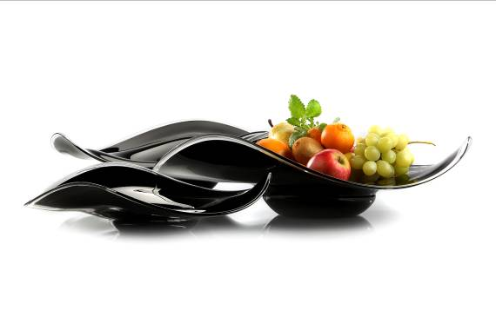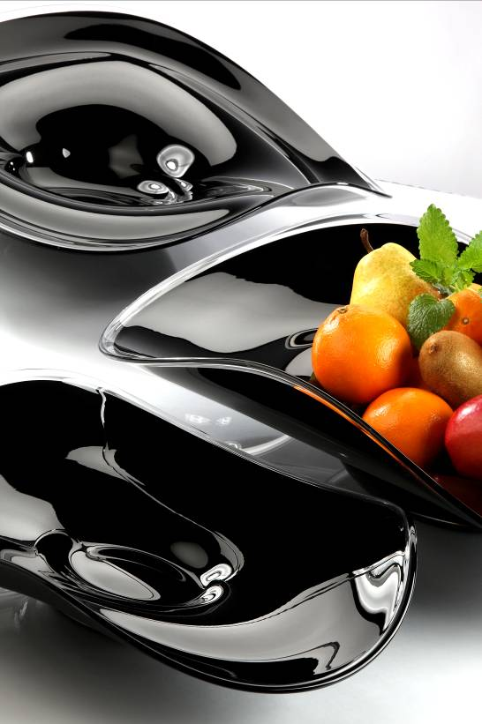

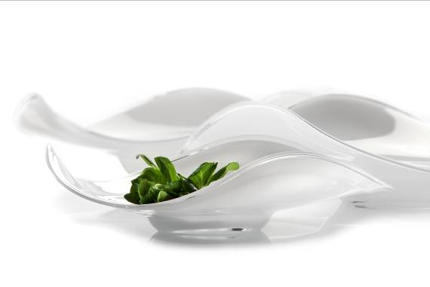

More information at: www.zieher.com

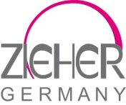03/2015
ZIEHER KG
Kulmbacher Straße 15 D - 95502 Himmelkron
Marketing: +49 (0)9273- 9273- 68; presse@zieher.com
In our press section on www.zieher.com you will find all press releases including visual material to download

