The charm of the ephemeral
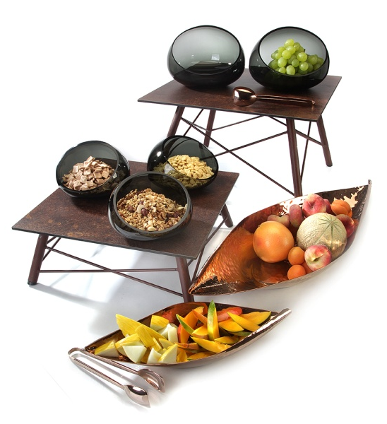
Break- and scratch-resistant, antistatic and dishwasher-safe - these features of laminated plastic platters and the resulting advantages are convincing!

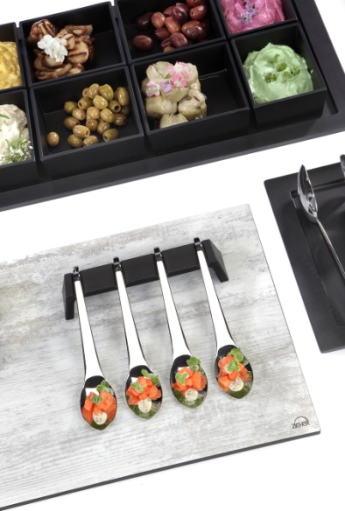
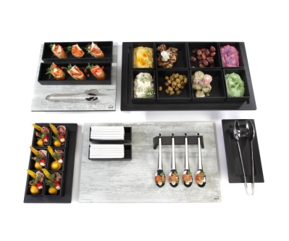
The ZIEHER-buffet platters made of laminated plastic are available in a neutral, dark grey version as well as in two extraordinary variations. The matured wood look, white "Vintage" decor is reminiscent of weathered and white discolored old wood planks. It emphasizes the radiance of imperfection and perfectly fits the furnishings of the attractive chalet style.

Unplastered brick-lined walls, load-bearing structural elements made of steel beams, exposed concrete and the morbid charms of abandoned factory buildings create the ambience for the rust-coloured decoration "Industry". This is evocative of weathered steel surfaces, which are marked by decades of corrosion.

All laminated buffet platters by Zieher have a dark middle layer and can be used on both sides due to having the decoration on both sides.

More information: WWW.ZIEHER.COM

