The “Splash“ – effect
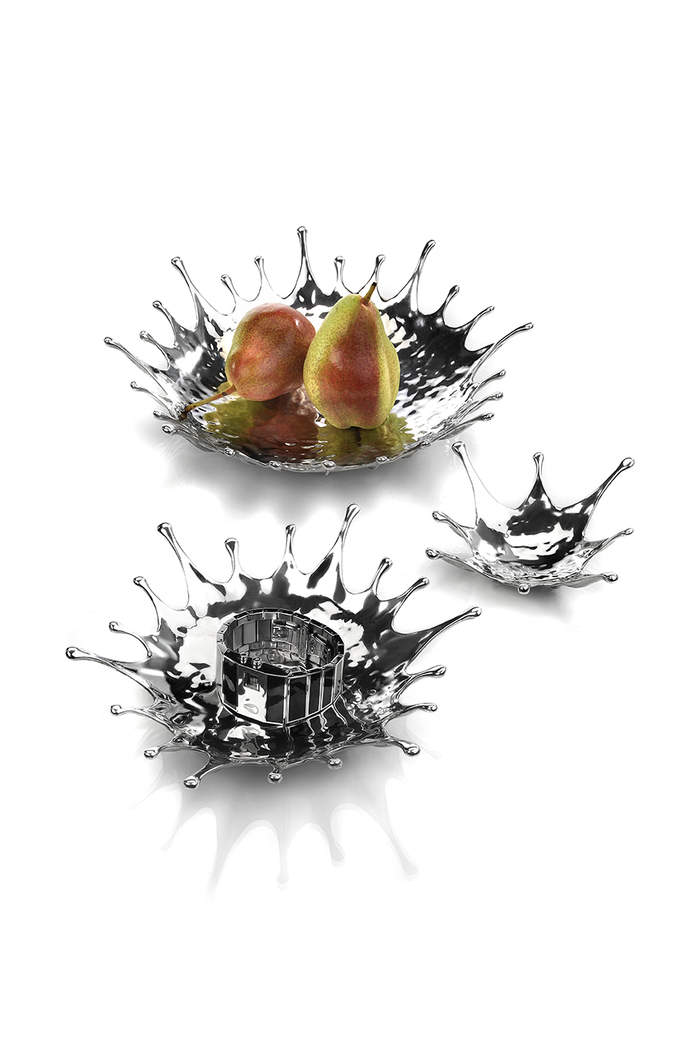
Dynamics of movement – solidified to a statue ! The bowls of the “Splash” series spread a very special flair by their playful optics! Whether used as fruit bowl in the big, for Amuse gueule / culinary delights in the small or as decorative deposit place in all varieties, “Splash” sets a charming course at the table and for interiors.

The bowls are made of solid pewter alloy, manually assembled of numerous single components and elaborately refined. Knobbed feet at the bottom side guarantee a safe stand.

More information: WWW.ZIEHER.COM



