Delicacies in delicate settings – presentation boxes made by Zieher!

Due to extensive accessories the small-sized box offers vast application possibilities.
The box, regularly fitted with a wooden sliding lid, can be equipped with several optionally available inserts made of top-quality solid surface material. The equally available lid made of sepia tinted glass is a perfect means to put anything presented inside the box in the limelight.
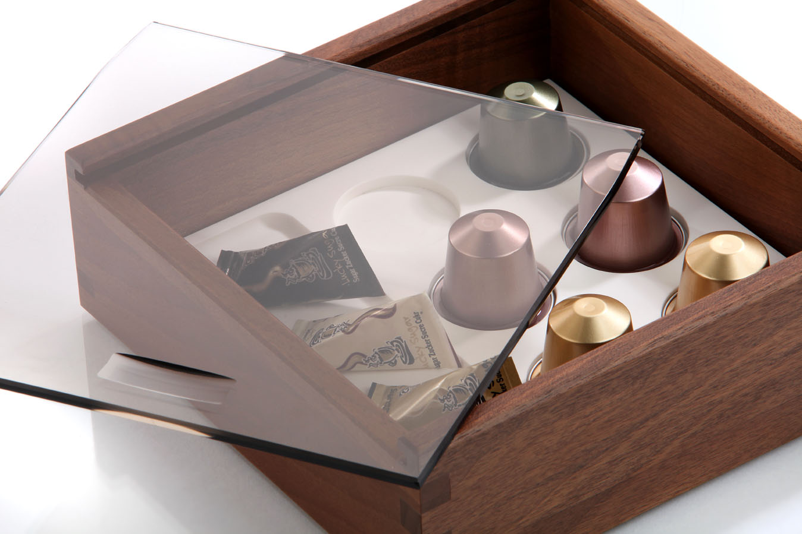The either black or white coloured inserts made of dishwasher proof and food safe solid surface material, are available in four versions.

Apart from an insert with round cavities for nine truffles/chocolates and a flat plate that can be used for layered chocolates, various little somethings or amuse bouches, there is also an insert available that can hold commercial coffee capsules. An additional version is the insert that can hold up to four cigars. A separate compartment on the side provides space for fitting accessories like matches or cigar cutters.
No matter if it is an assortment of coffee specialities or various delicacies of the pâtisserie, the presentation box by Zieher provides the perfect setting for many purposes.

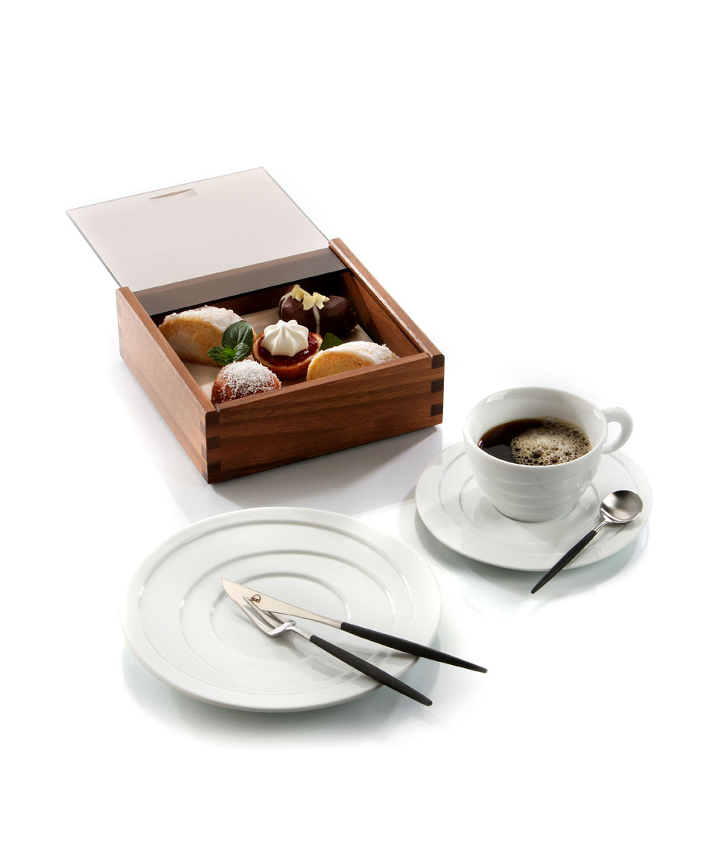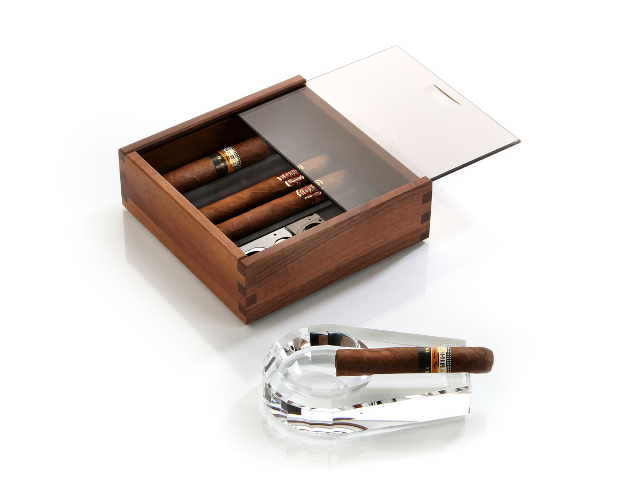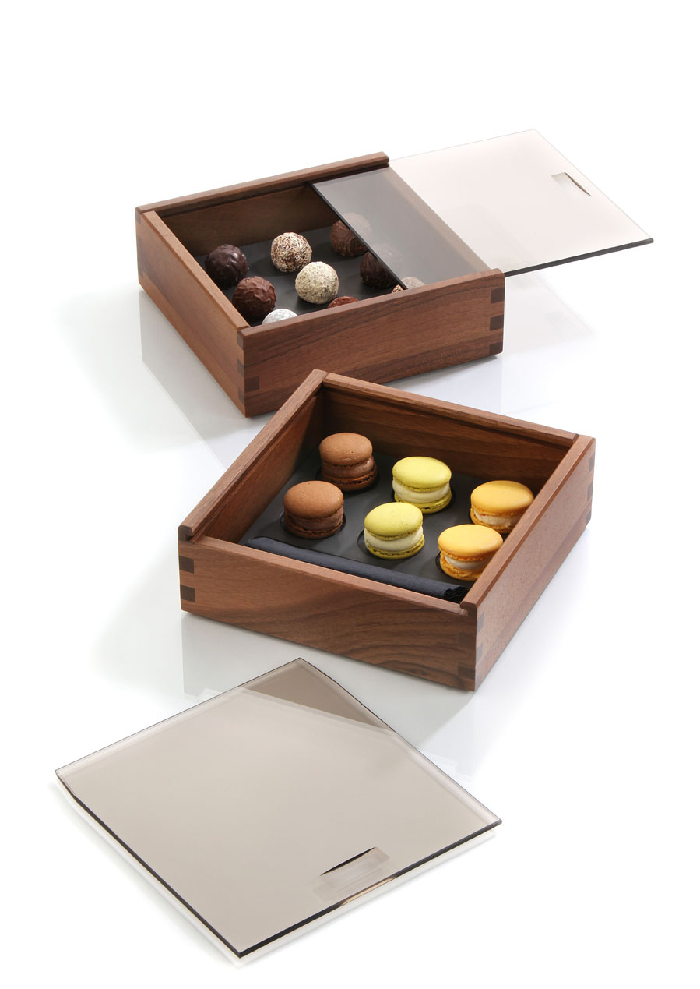

More information at: www.zieher.com

03/2015
ZIEHER KG
Kulmbacher Straße 15 D - 95502 Himmelkron
Marketing: +49 (0)9273- 9273- 68; presse@zieher.com
In our press section on www.zieher.com you will find all press releases including visual material to download

