„Solid“ – Buffet cubes!

The multiple use buffet cubes of the „Solid” series are made of massive walnut, like all the other items of this series. They may be used as containers for cutlery or French bread, but they are particularly suitable for the elevation of the „Modul” walnut trays or other buffet platters.

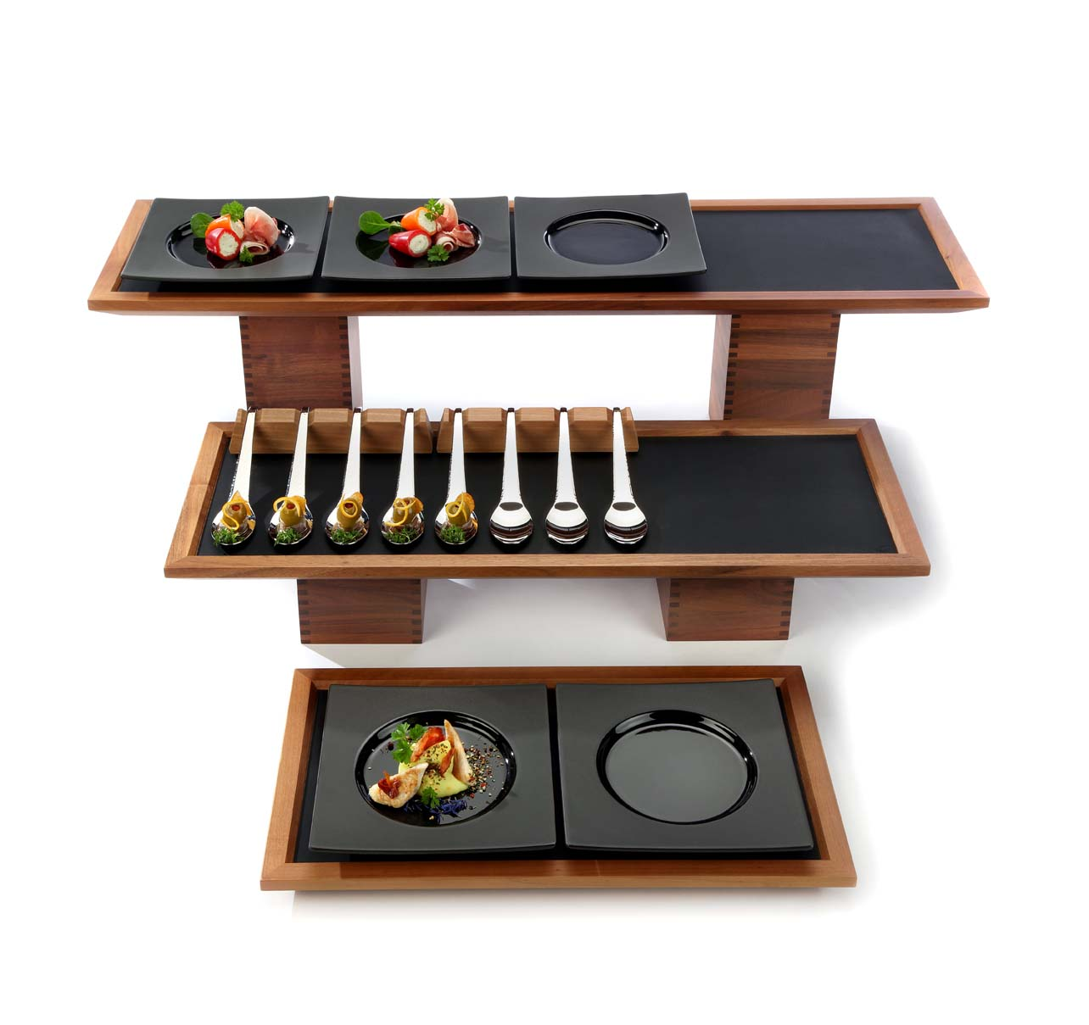The filigree finger joints around the corners testify to precise craftsmanship of the highest quality and guarantee perfect stability!

This perfect fit in combination with a food safe sealing ensures a long life span, even in daily use.

The cubes made of solid wood are visually appealing and fit perfectly into the existing
buffet system „Solid”. This series satisfies by its many possibilities to arrange a buffet set-up.

The walnut series „Solid” further consists of bowls, trays, bread and cereal baskets, tray holders, cutting boards and an extensive breakfast/bread buffet.

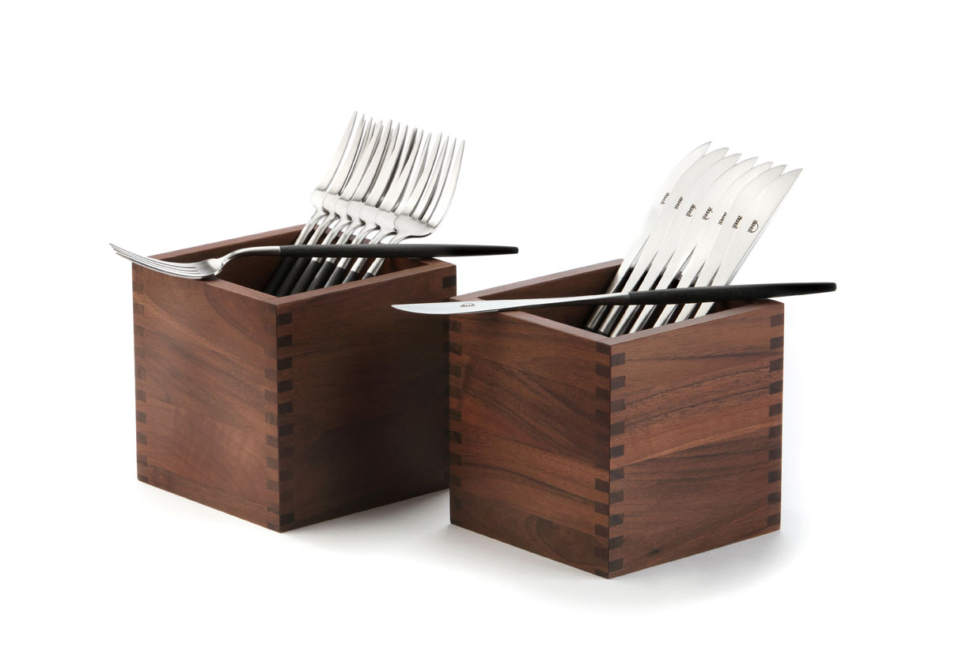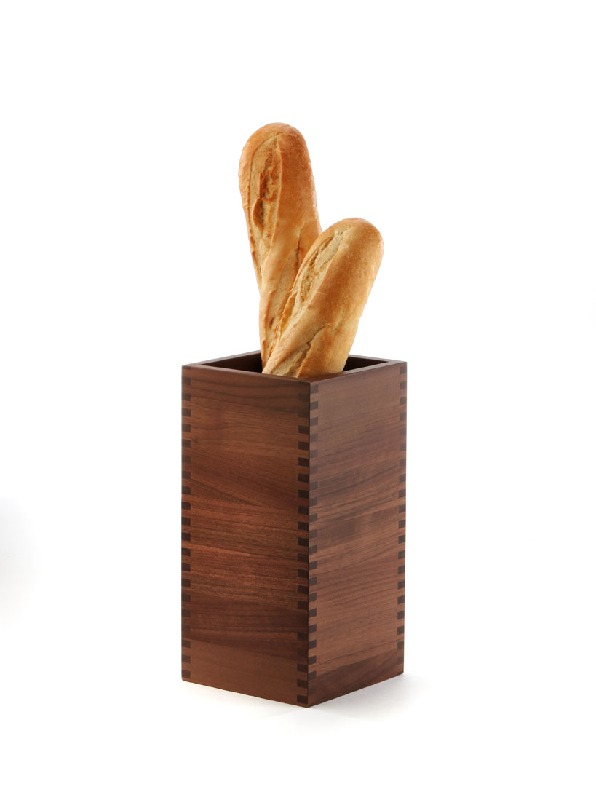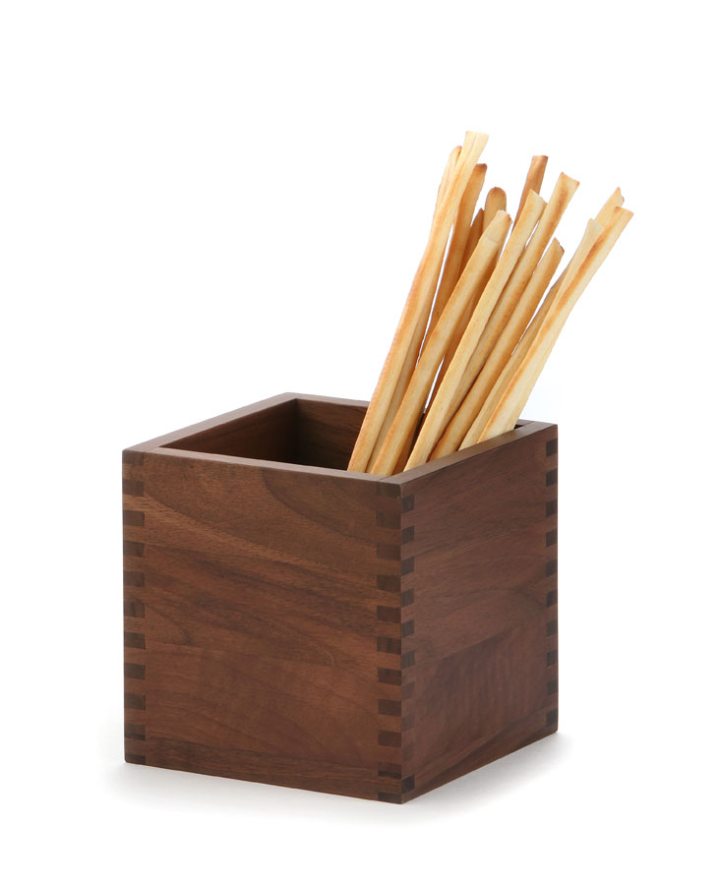
More information at: www.zieher.com

