„DressCoat“-Etagere

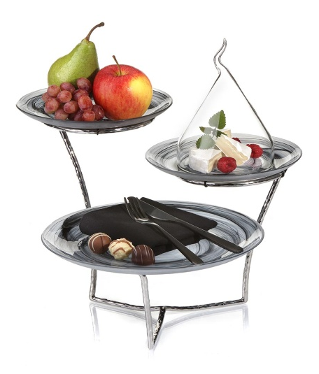
The etagere with three tiers, made of hammered and highly polished stainless steel, forms an extravagant basis for many sorts of plates and platters. The supporting rings with a diameter of 15 cm offer the possibility to insert not only plates and platters, but alternatively also bowls. Small black silicone rings keep inserted porcelain in position and prevent annoying clattering.

A very special aesthetic set-up can be arranged by using a combination of several etageres along with the biggest plate of the “DressCoat” series. Numerous presentation areas on a total of four different levels can be created by placing additional plates directly on the table. The diameter of 22 cm is more than sufficient to put different pralines, petit fours and other creations of confectionery into the limelight in an impressive way.

In connection with the almost invisible tier stands the porcelain tablecloths appear amazingly airy and playful by their floating look-and-feel. A buffet presentation with an elegant vibrancy caused by the drapery of the “DressCoat” plates – that’s where it comes into its own!

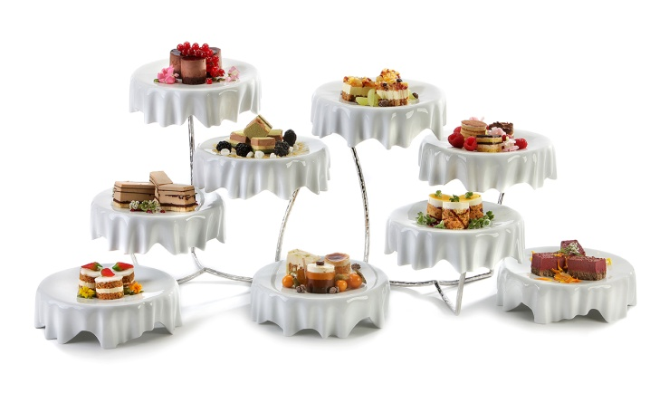
Even in the hotel room the etageres can be positioned in an eye-catching way. Equipped with “DressCoat” or other tableware, small snacks, a selection of fruit or a sweet welcoming treat can be staged in an appealing way.

More information: WWW.ZIEHER.COM

