“Table-Trees” - alluring variety on the table

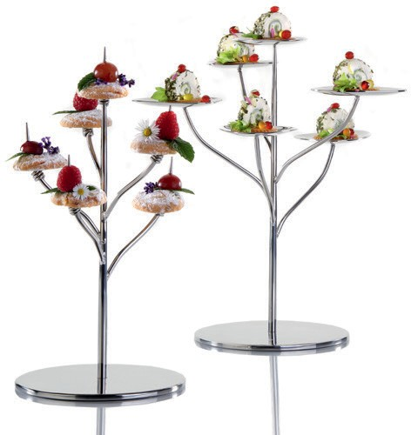For the presentation of filigree delicacies on a minimum of space, the new “Table- Trees“ from Zieher offer numerous options for stylish staging.

On the six organically shaped leaves of the “Flower - Table-Tree”, dessert variants, an intermediate course or a little amuse-bouche for one or more guests can be presented. Even a selection of fruit, pastry or pralines can be attractively served.

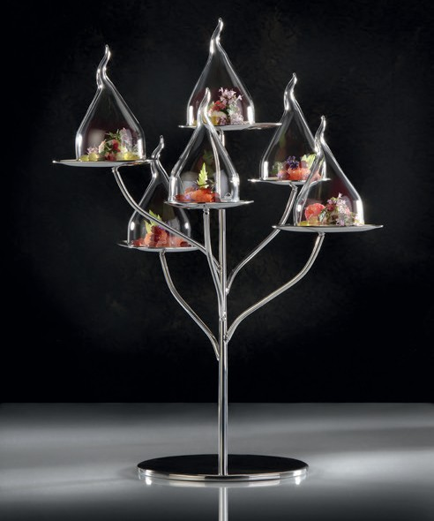The “Pin - Table-Tree” provides surprising moments, offering the opportunity to serve finger food or small snacks on six skewers at dif- ferent heights. Melon with ham, dates wrapped in bacon or tastefully filled parmesan baskets and edible flowers find an attractive place on the elegant branches. Every delicacy is held securely by an artfully shaped spiral and prevented from slipping.

Using solely stainless steel, the 30 cm high “Table-Trees” are com- pletely handcrafted and polished to a high gloss. The solid pedestal forms the basis of these filigree products and ensures a firm stand.

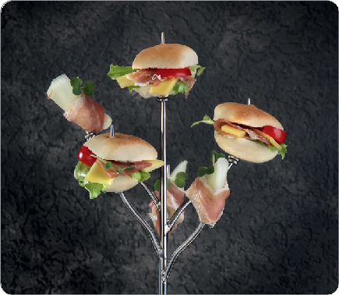The trees can also be used on the buffet and are a nice addition to the larger exemplars of the „Flower-Tree“ family. These are available in two versions and offer with up to 72 cm high, 13 or 25 levels for the presentation of culinary delights.

WWW.ZIEHER.COM

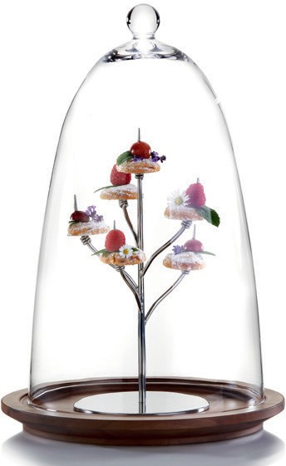

09/2020
Zieher KG, Kulmbacher Straße 15, D - 95502 Himmelkron • marketing: +49 9273 9273-68 • presse@zieher.com
In our press area on www.zieher.com you will find all press releases including visual material to download.

