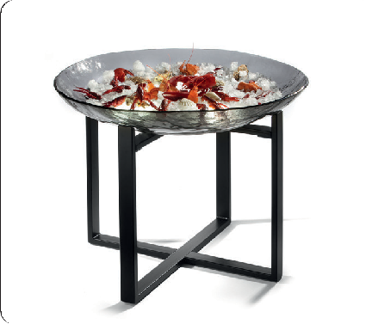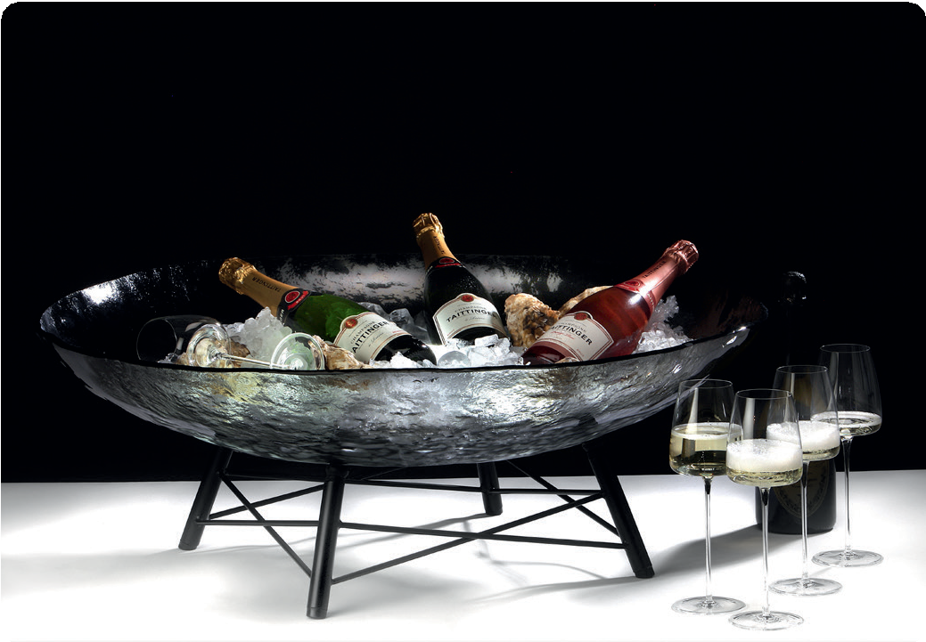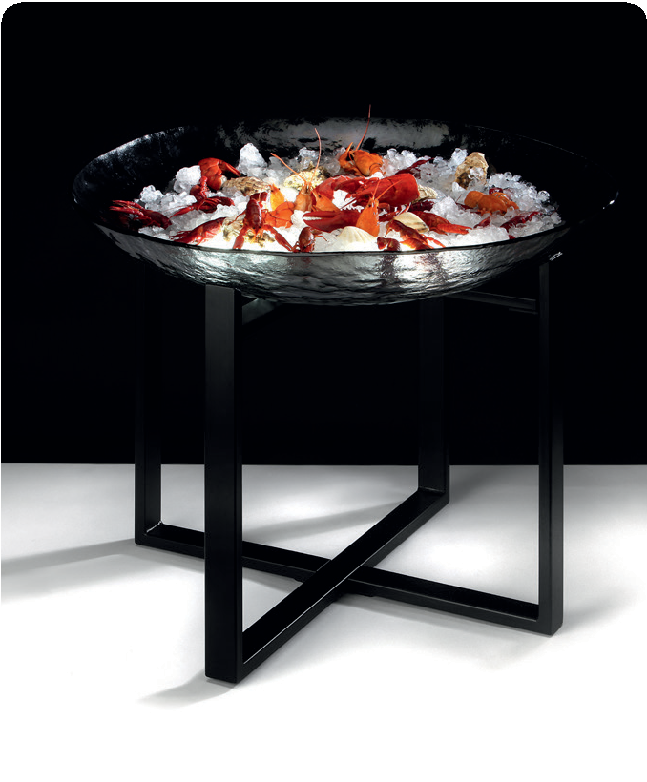“XXL-bowl“ - like a sculpture!

This monumental bowl made of dark grey glass arches like a sculp- ture and melts optically with crushed ice to stage classy seafood or champagne in an opulent way.

In combination with the Zieher rechargeable LEDs, which perfect- ly accentuate the irregular structure of the glass, the presentation
becomes even more dramatic! This effect is further intensified by the optical refraction of the ice.

This impressive bowl with a diameter of 82 cm can be placed free-standing on the floor by using the fitting rack. But also right at the buffet table or arranged together with the stands of the
“Crossline” series in different heights, these designer pieces know
how to impress.

More information:
WWW.ZIEHER.COM

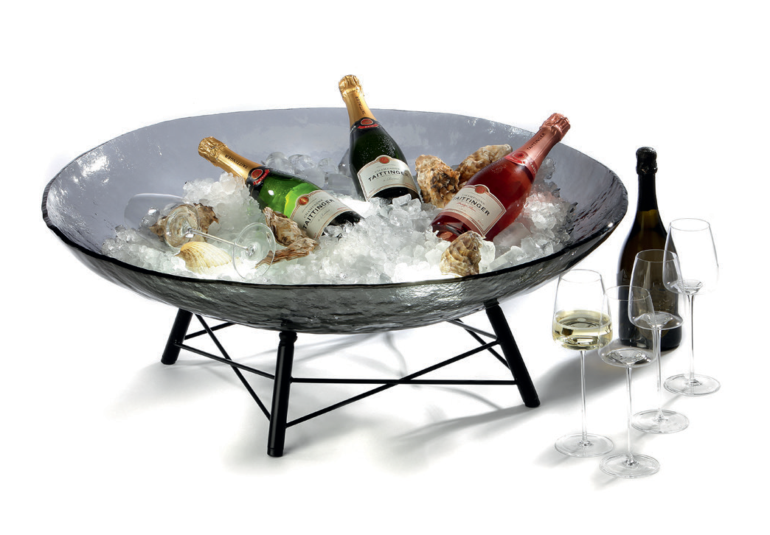

03/2020
Zieher KG, Kulmbacher Straße 15, D - 95502 Himmelkron • marketing: +49 9273 9273-68 • presse@zieher.com
In our press area on www.zieher.com you will find all press releases including visual material to download.

