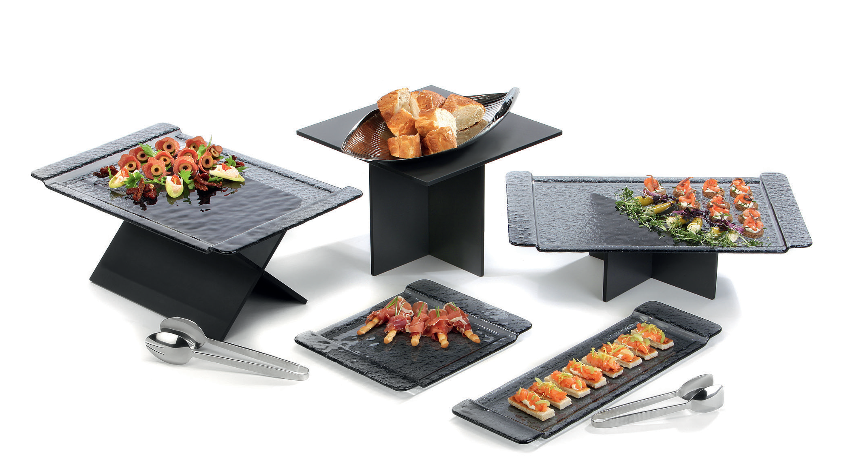“StiXXX” - indestructible plug-in!

The indestructibility of laminated platters meets the advantages of plug-in systems. The plain displays are loosely stuck together, which ensures a quick and uncomplicated set-up as well as a space-saving storage of the single components. Thereby “StiXXX” meets in par- ticular the hard requirements of daily use in the catering business.

The heights of the puristic displays match perfectly with other series of the Zieher-System, by what creates numerous possible combina- tions. Positioned as an “X” results in further presentation possibilities with a particularly slight and filigree alignment.

The Zieher buffet platters and displays made of laminate are usa- ble on both sides by the double-sided decoration. This exceedingly robust raw material is break- and scratch-proofed, antistatic and dishwasher safe and thus offers numerous advantages compared to other raw materials.

More information:
WWW.ZIEHER.COM

03/2020
Zieher KG, Kulmbacher Straße 15, D - 95502 Himmelkron • marketing: +49 9273 9273-68 • presse@zieher.com
In our press area on www.zieher.com you will find all press releases including visual material to download.

