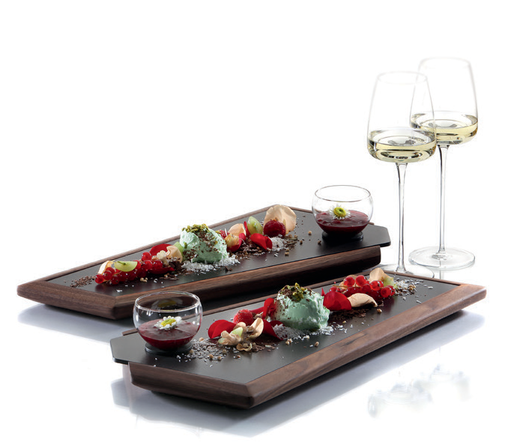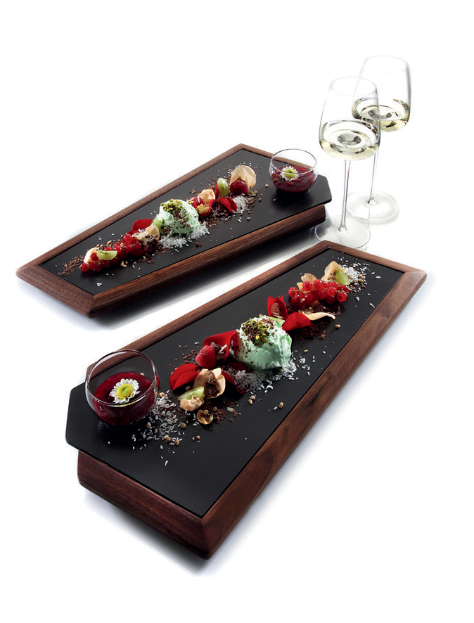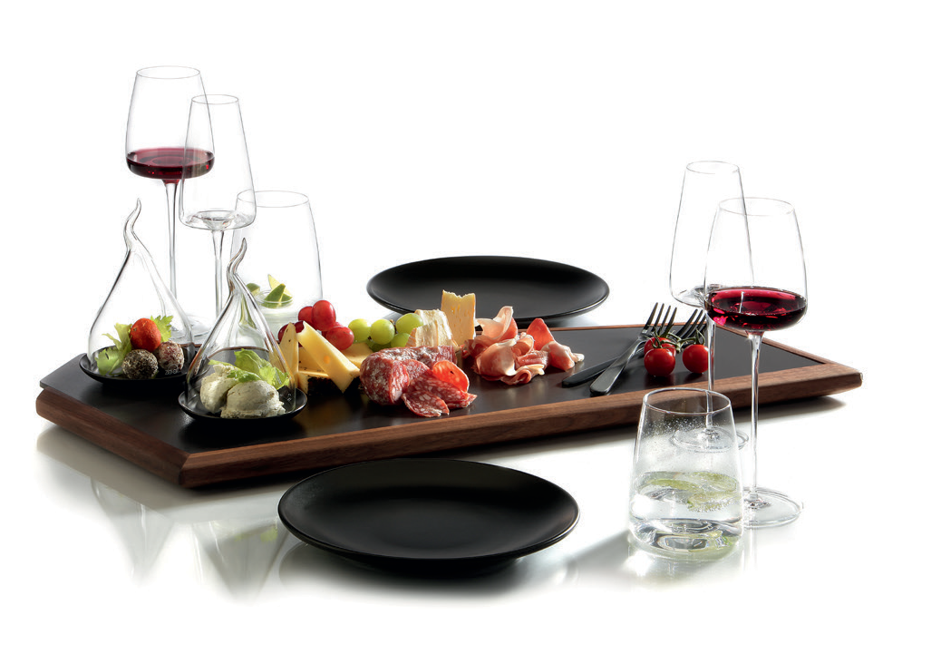Enjoyment in a pentagon!

These classy service platters take effect by their exceptional shape and the stylish combination of oiled walnut wood and slate grey ceramics.

Available in two different sizes for just one or more persons, single courses right up to mixed arrangements - so-called “sharing plates” - can be staged appealingly.

For bigger buffet set-ups, several plates can be arranged space- saving and thus provide an extraordinary structuring of the buffet spaces. The pentagonal design allows numerous arrangements
- as a result, beautiful presentation areas for regional delicacies, desserts, antipasti and much more can be created.

The projecting handle permits an easy removal of the insert and thus allows an uncomplicated cleaning of the thin but very robust ceramic.

More information:
WWW.ZIEHER.COM

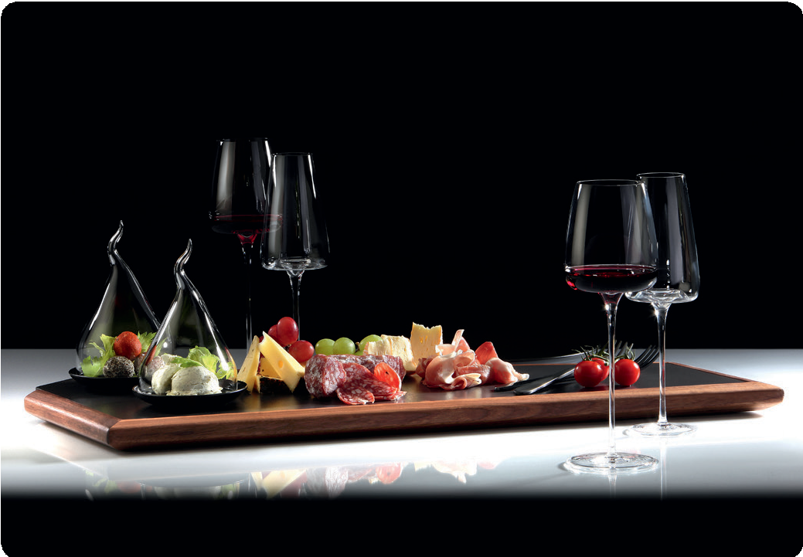

03/2020
Zieher KG, Kulmbacher Straße 15, D - 95502 Himmelkron • marketing: +49 9273 9273-68 • presse@zieher.com
In our press area on www.zieher.com you will find all press releases including visual material to download.

