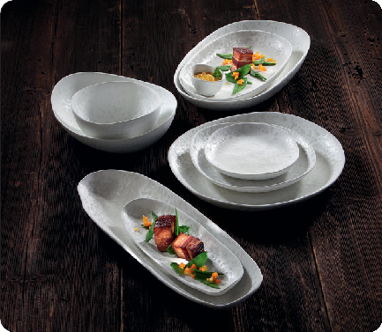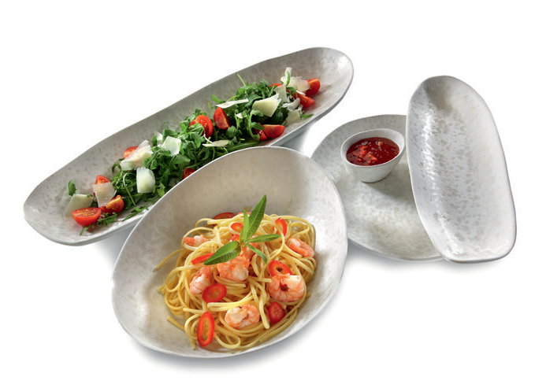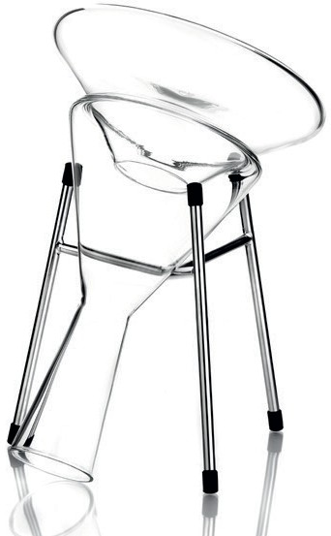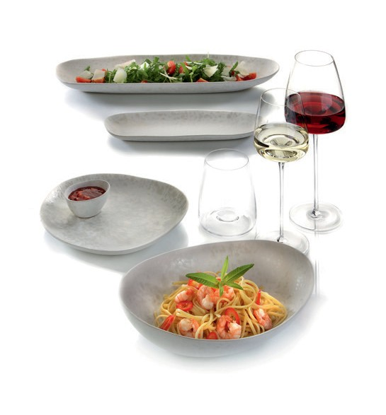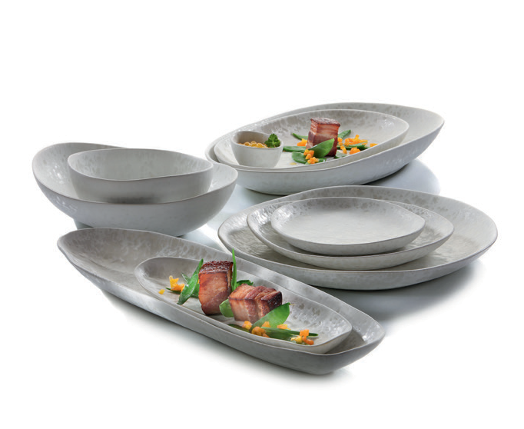“Salar” - nature as a model

In contrast to the uniform results of industrially mass-produced goods, the imperfection and individuality of hand-made ceramics im- press in creating a very charming and natural look. This charm of the imperfect is particularly evident in the organically shaped plates and platters of the 10-part series “Salar”.

Softly rounded shapes as well as mysterious surface structures that are reminiscent of archaic salt lakes, create unique items enchanting again and again and form a subtle stage for extraordinary dishes with their ivory-coloured base tone.

The effect glaze used impresses with its matt and glossy, almost mother-of-pearl shimmering areas and its irregular spreading creates individual pieces with a very special appearance. It looks archaic but still elegant and noble.

“Salar” acts humble in an elegant way and places the dishes on display in the centre of attention. Nothing hinders a combination with other shapes or materials, “Salar” is predestined for diversity on the set table. Mix & match is the motto.

WWW.ZIEHER.COM

03/2021
Zieher KG, Kulmbacher Straße 15, D - 95502 Himmelkron • marketing: +49 9273 9273-68 • presse@zieher.com
In our press area on www.zieher.com you will find all press releases including visual material to download.

