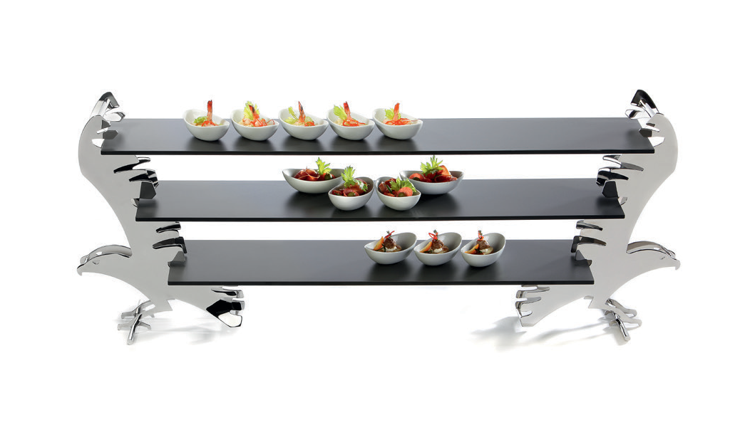 “Falcon” - really detached!
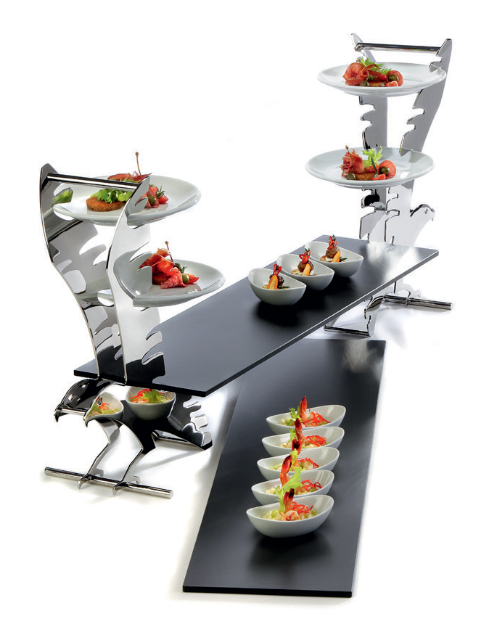
This etagere, inspired by the elegance of a falcon, is giving wings to the creativity at the buffet. A single one can bear up to three plates on its wings or, when used as a duo, fitting buffet platters or a combination of both can be installed. Anti-slip supports can
be plugged on if needed and thus provide a safe positioning of the
platters.

As a high-tea stand, the etagere carries plain white coup plates or matt-black plates with a slate-like structure. Those plates fit exactly into the slots of the wings.

The mirror polished, solid stainless steel (3 mm) punctuates the precious impression of the dynamic shape, incorporated handrails facilitate the service. This majestic creature is sitting on a stylized branch, which also provides a firm stand.
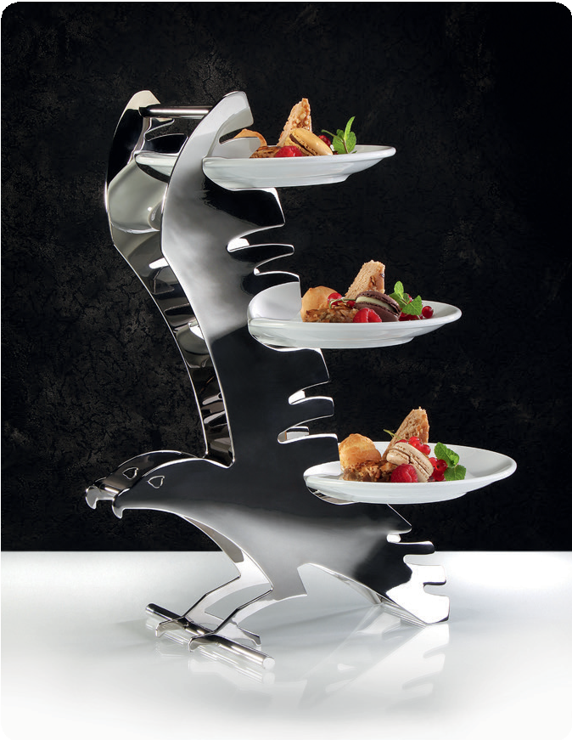

More information:
WWW.ZIEHER.COM

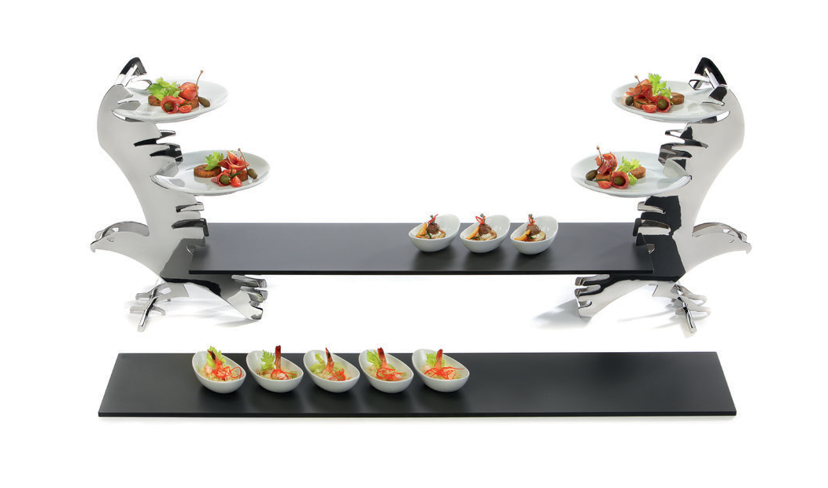

03/2020
Zieher KG, Kulmbacher Straße 15, D - 95502 Himmelkron • marketing: +49 9273 9273-68 • presse@zieher.com
In our press area on www.zieher.com you will find all press releases including visual material to download.

