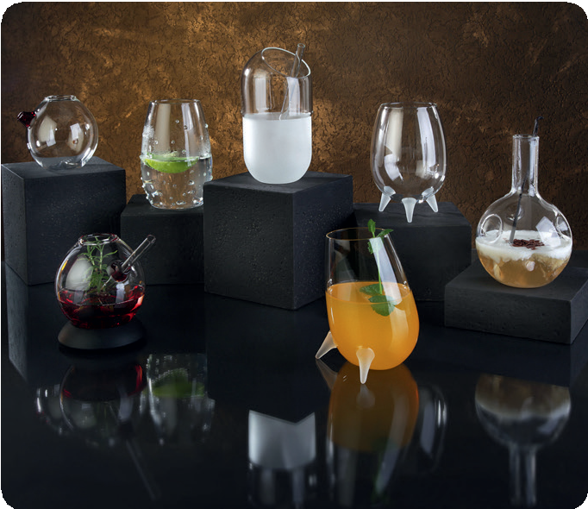THE BAR COLLECTION by Zieher enriches the bar scene with new characters which are predestined for independent creations beyond the cocktail mainstream. Each jar playfully picks up on a different the- me and thus exudes a good portion of humor in its own way.

Made of particularly break-proof and temperature-resistant borosilicate glass, all glasses not only offer an extravagant outer shell, but with a capacity of up to 500 ml, also provide plenty of space for extraordinary experiments and countless recipes. Despite their differences, all glas- ses (AMUSE, THE KNOBBED, THE PILL, THE VIKINGS and EDDY
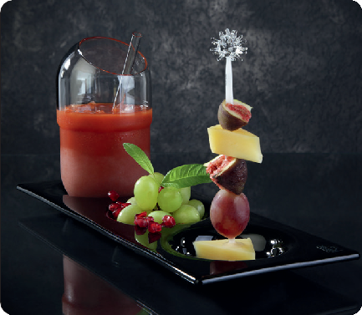
- DASH!) are easy to combine.

Matching accessories, such as trays and straws, made of glass or an unusual skewer made of borosilicate glass create possibilities that go far beyond serving a drink. Besides the taste, a haptic and visu- al experience is generated as well, which fulfils the basis of modern cocktail staging.

“The Pill”
“The Pill” allows for many associations: The risks and side effects of
the drinks served in these glasses range from the feeling of well-being
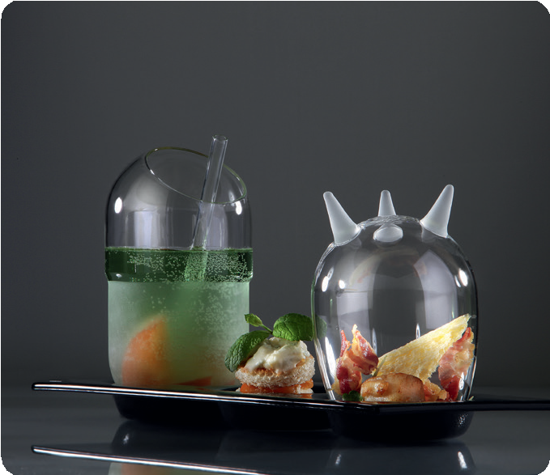after consuming various healthy drinks to the intoxicating effects of high-proof cocktail creations.

“The Vikings”
“The Vikings” are vaguely reminiscent of the headgear of ancient Vi- kings. They offer a large, clear chalice on satined feet, in which strong cocktails can be staged transparently. The variant with two feet surpri- ses with its tilted position, while the three-foot variant appears stable and yet almost floating.

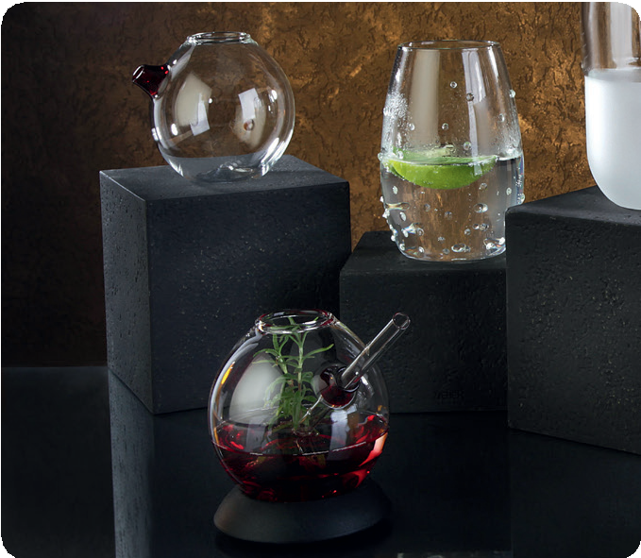“The Knobbed”
“The Knobbed” plays with its content, because the attached knobs imitate the bubbles of carbonic acid in an amusing way. Interesting contradictions to the actual content can be taken to extremes here.

“Amuse”
A nice addition to the series is the “Amuse” pourer, which fits in well with the collection. The pourer made of red glass sets a playful colou- red accent and is suitable for glass straws with a diameter of up to
8 mm.

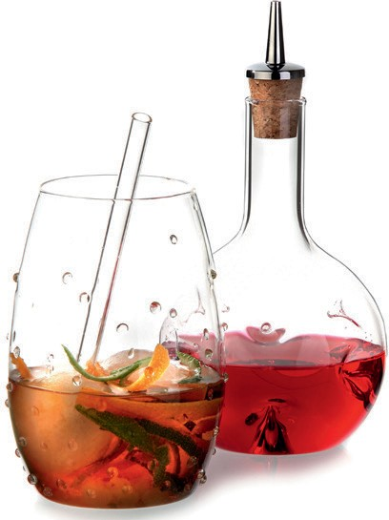“Eddy - dash!”

The dash bottle “Eddy - dash!” for dosing bitter or sour ingredients is, alongside the glasses, an important part of THE BAR COLLECTION. A fitting squirt dispenser comes with every bottle. This vessel is for- mally based on the well-known “Eddy” wine decanters from Zieher and, in addition to being used as a dash bottle, also enables further uses. Thus, for example, a “cocktail from the bottle” can be served in these vessels, the inwardly directed swirling bodies allow the ingre- dients to be mixed right before the drink is enjoyed.

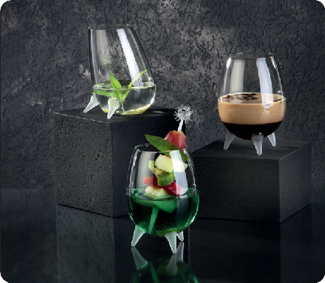
The smallest “Eddy” can also be used in the restaurant. For this pur- pose, Zieher offers suitable cruets as well as matching bottle pourers with hygienic sealing caps, which allow the “Eddy - dash!” to be used as an oil or vinegar bottle.

WWW.ZIEHER.COM

