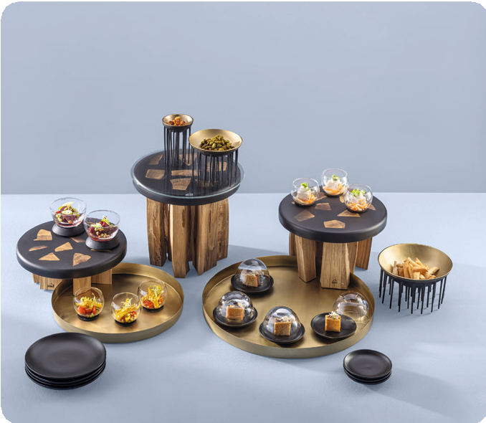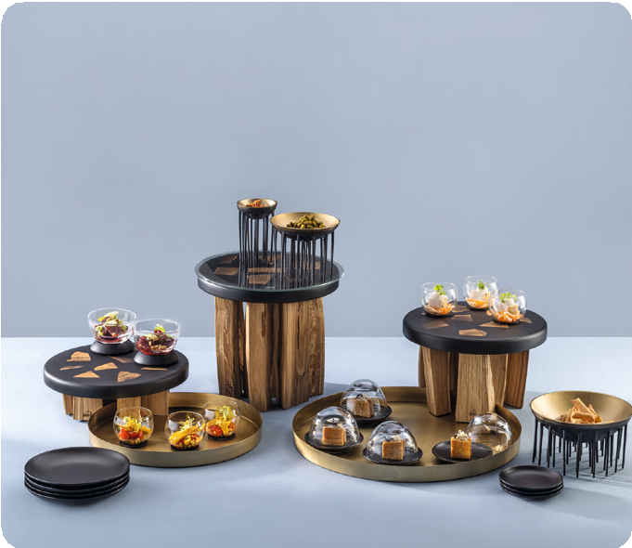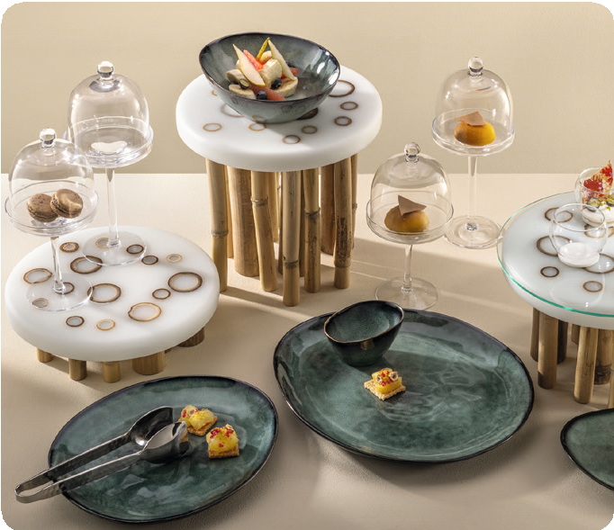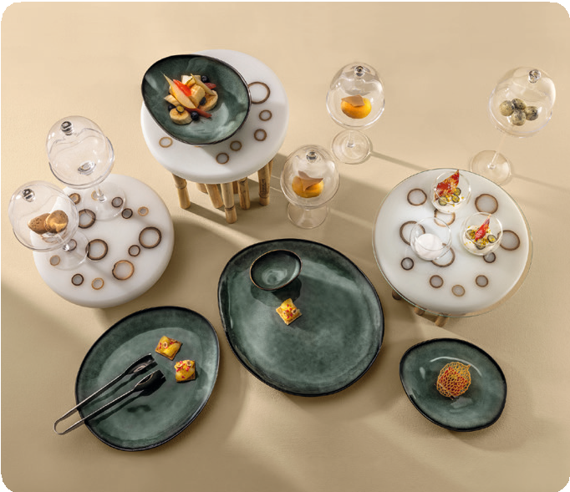Unique like nature! “Stomp!” & “Sagano”

The desire for individuality and handmade, unique pieces is perceptible in all sections of the hotel business. Besides distinctive elements in architecture and interior, guests should also experience uniqueness at the food presentation on the buffet.

“Stomp!” and “Sagano” are taking up this trend and playfully connect it with the tamed power of nature.

Pieces of solid oak wood, split by an axe, carefully oiled and individually arranged form the basis of the “Stomp!” buffet displays. These ethnic elements of nature are cast in anthrazite, but nevertheless slightly translucent resin and thus durably fixed in their arrangement. The silk matt finish of the dark coloured resin forms a harmonic contrast to the oiled oak wood. The combination of “Stomp!” with items made from solid brass results in a solemnly, almost mystically atmosphere.

In contrary to “Stomp!”, “Sagano” fascinates by its playful airiness and filigree vibrancy. Feathery bamboo poles in different diameters are composed in white resin. Here, the visible rings on the top of the display create diversified, almost graphical effects.

Both lines have the same concept, but the final appearance is quite opposite and yet easy to combine. Each display is one of a kind and absolutely unique.

The resin used in both series is food safe and was refined with a silk-matt finish and finally oiled. So, in case of wear in daily use, the surfaces can easily be refreshed.

To protect these surfaces, but also to arrange food directly on the displays, optionally available glass plates can be placed on top if needed and can also be replaced by new ones quickly.

WWW.ZIEHER.COM

03/2023
Zieher KG, Kulmbacher Straße 15, D - 95502 Himmelkron • marketing: +49 9273 9273-68 • presse@zieher.com
In our press area on www.zieher.com you will find all press releases including visual material to download.

