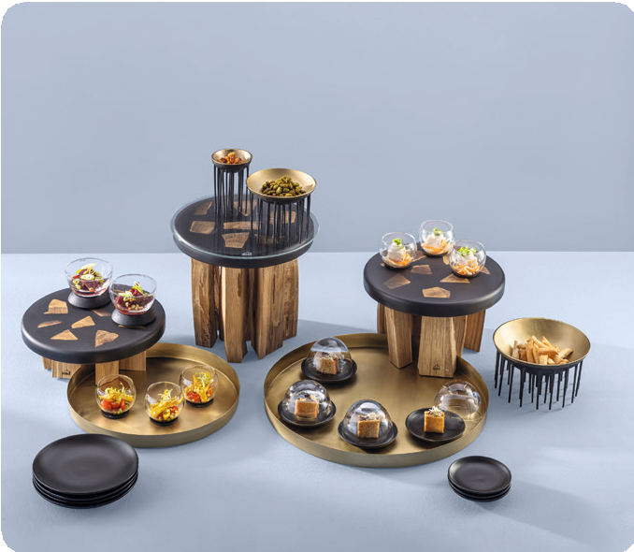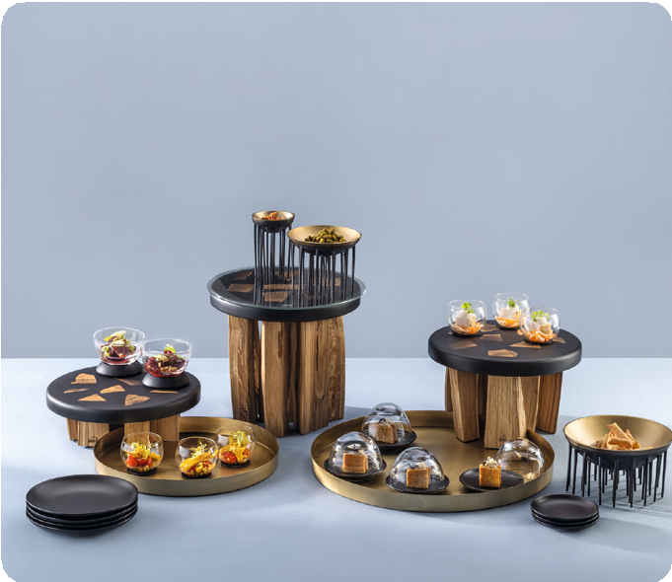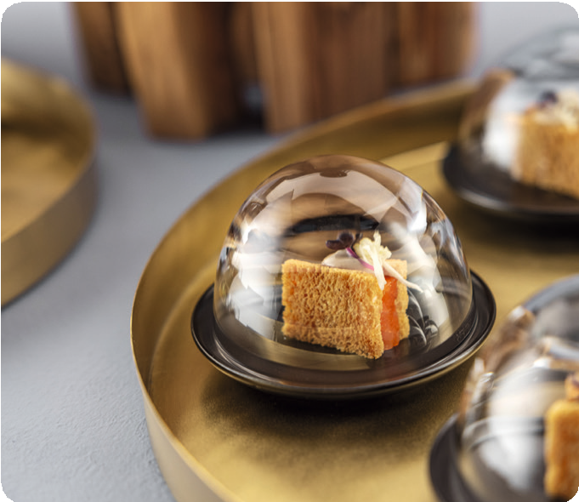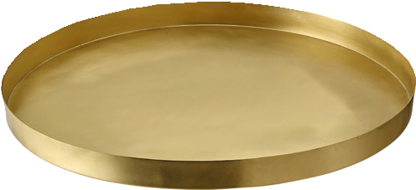Brass trays “Orbis”

The service trays “Orbis” are made of solid brass and furnished with a matt surface structure. The modern appearance of these products results from the matt-golden tint and the reduced creation.
The trays are available in two sizes and predestined for the use in a bar, on the buffet or the service in a restaurant.

All trays are food-safe sealed, nevertheless the direct contact with food should be avoided. Primarily, the varnishing prevents from too rapid formation of patina, which is inevitable for brass. In the long term, this patina is actually desired as it is exactly this matured colour, occurring in the course of time and use, which exudes a very special charm. By and by, these trays become more and more beautiful, each piece evolves into a unique copy.

WWW.ZIEHER.COM

03/2023
Zieher KG, Kulmbacher Straße 15, D - 95502 Himmelkron • marketing: +49 9273 9273-68 • presse@zieher.com
In our press area on www.zieher.com you will find all press releases including visual material to download.

