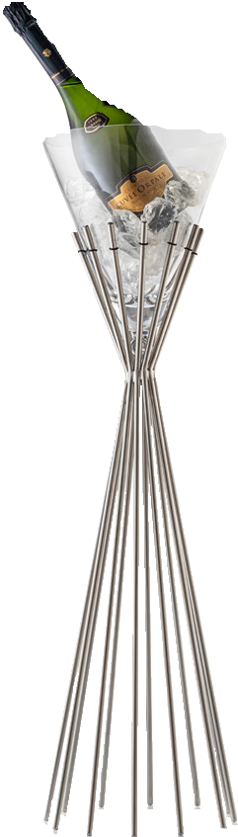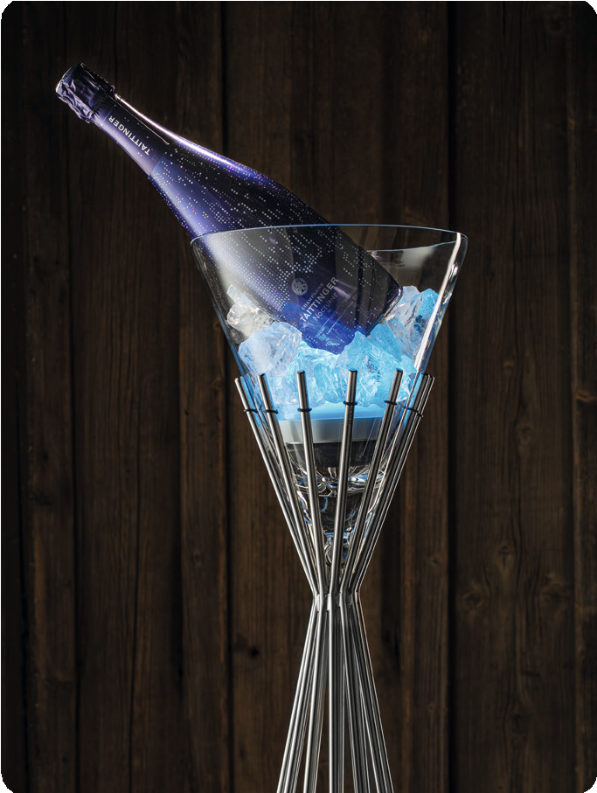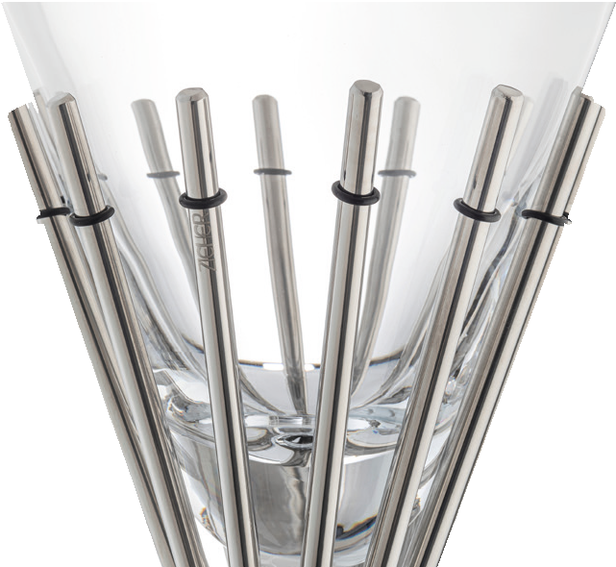“Mikado“– cool staging!

The bottle cooler “Mikado” is made of solid stainless steel and high gloss polished. Due to its weight and the generously dimensioned floor area, the solid frame has the required stability to offer the matching cooler made of hand-blown glass a secure hold.

Additional silicone rings on the upper side of the rods treat the glass body with care and avoid disturbing noise.

A very special highlight creates the optional available waterproofed LED light which can be placed right inside the cooler. Multiple colours and functions can be adjusted by a remote control, an optionally available supporting ring keeps the light in position.

Optionally, the glass insert of the “Mikado” bottle cooler can also be used as cloche. The reinforced quality, which is indispensable for the usage as cooler, implicates besides the slightly higher weight also an obviously improved stability. The integrated ball grip at the top provides a easy handling when used as a cloche.

Design: Itamar Harari

WWW.ZIEHER.COM

03/2023
Zieher KG, Kulmbacher Straße 15, D - 95502 Himmelkron • marketing: +49 9273 9273-68 • presse@zieher.com
In our press area on www.zieher.com you will find all press releases including visual material to download.

