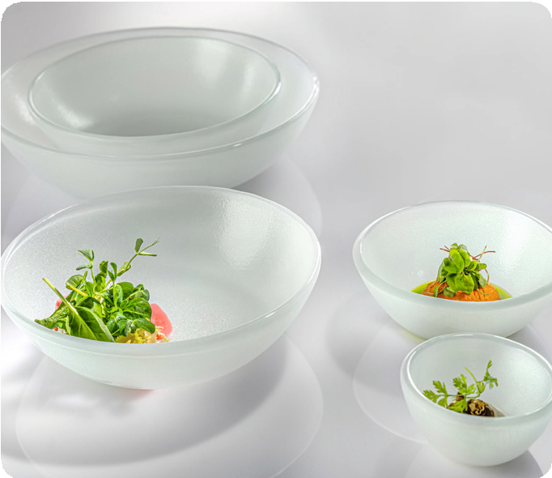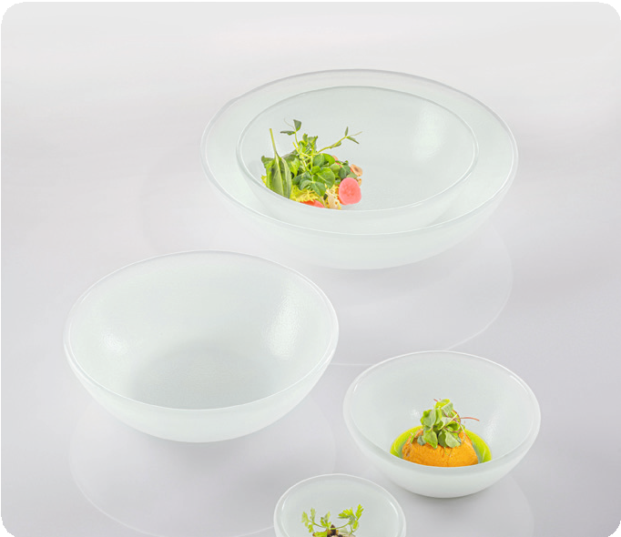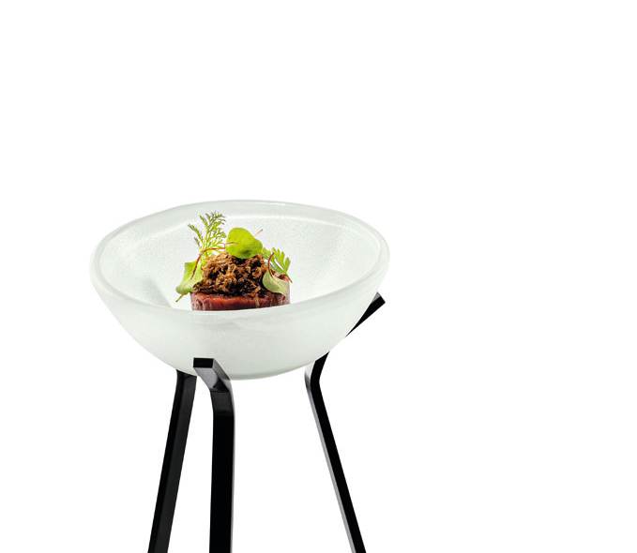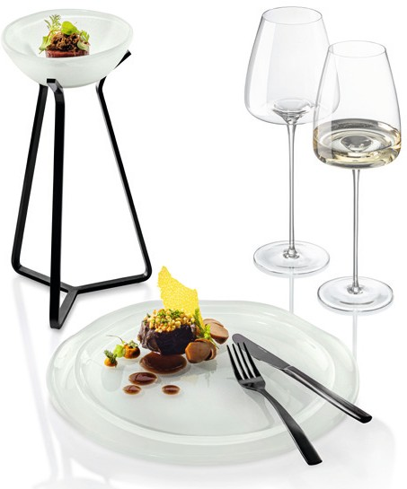“Gelo”

The glass plates and bowls of the “Gelo” series set frosty accents and convey a high valence on the set table by their satined surface and robust style. The bowls, which feature a slight structure on the inside, harmonise very well with the smooth surface of the organically shaped plates. All items of this series are made of extra white special glass which, compared to standard glass, contains a significantly reduced green component.

In combination with the DryPod display, individual creations can be highlighted and presented on a different level.

WWW.ZIEHER.COM

Bild WEIWEIN + Drypod

03/2023
Zieher KG, Kulmbacher Straße 15, D - 95502 Himmelkron • marketing: +49 9273 9273-68 • presse@zieher.com
In our press area on www.zieher.com you will find all press releases including visual material to download.

