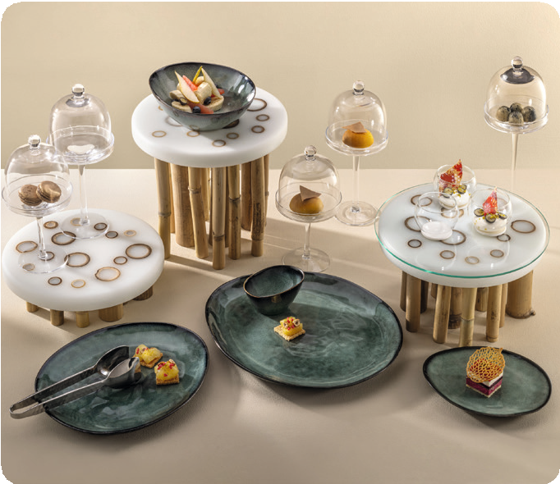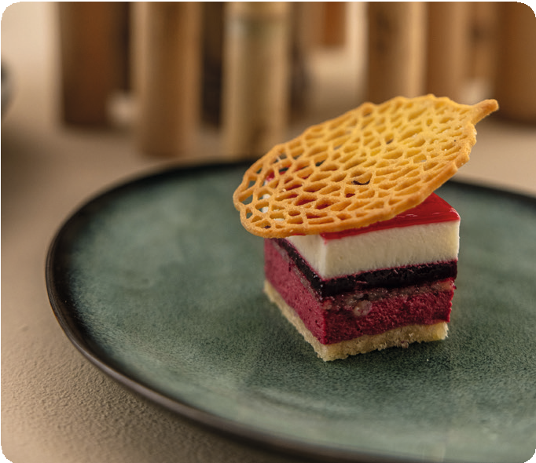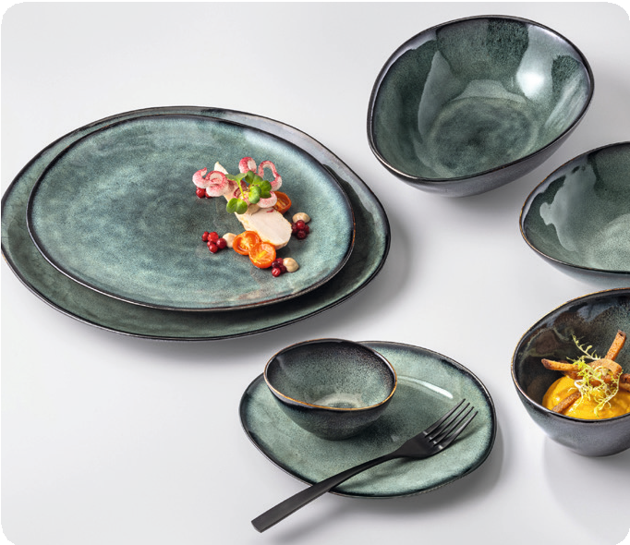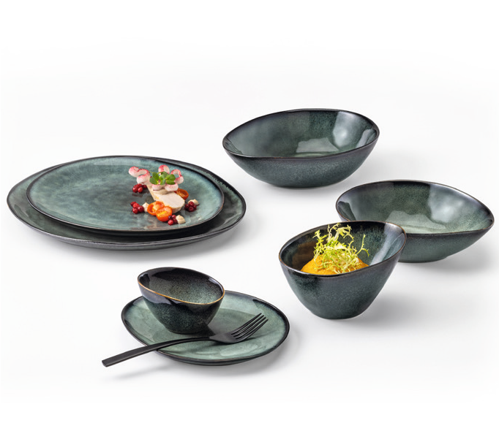„Bosque“ – a breeze of enchanted forest

The imperfection and individuality of handmade ceramics convinces, opposite to the standardised results of industrial manufactured bulk goods, by its very charming and natural flair.

It’s only the used reactive glaze that awards the organically shaped plates and bowls of the ceramic series “Bosque” their very special charm. These effect glazes react during the firing process with special ingredients and thus create fascinating patterns which are basically similar but never identical. They emphasise the handmade character of the crockery and make each piece unique.

With “Bosque”, a play of colours of different shades of green, blue and grey is created in fascinating gradients and effects that exude an elegant vibrancy and a festive mood.

WWW.ZIEHER.COM

03/2023
Zieher KG, Kulmbacher Straße 15, D - 95502 Himmelkron • marketing: +49 9273 9273-68 • presse@zieher.com
In our press area on www.zieher.com you will find all press releases including visual material to download.

