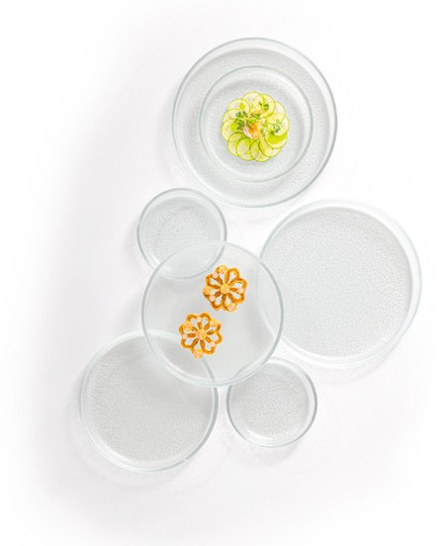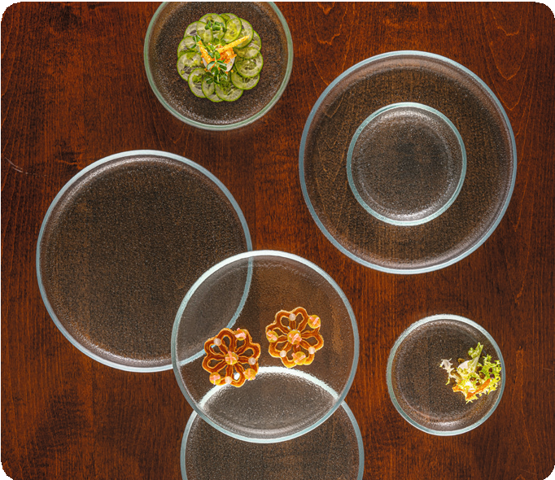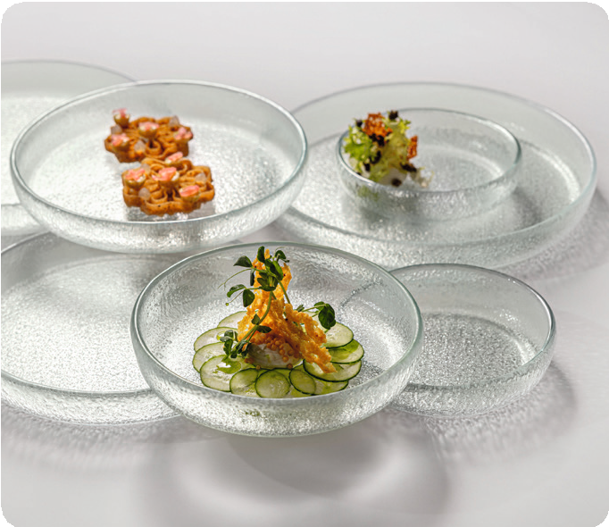“Bolla”

The reluctant design and plain geometry of these plates result in a perfect basis for the modern staging of premium dishes. The rampant elevated rim creates sufficient space, the subtle structure of the almost pure white glass also optically forms the frame for extraordinary dishes of the haute cuisine.

WWW.ZIEHER.COM

03/2023
Zieher KG, Kulmbacher Straße 15, D - 95502 Himmelkron • marketing: +49 9273 9273-68 • presse@zieher.com
In our press area on www.zieher.com you will find all press releases including visual material to download.

