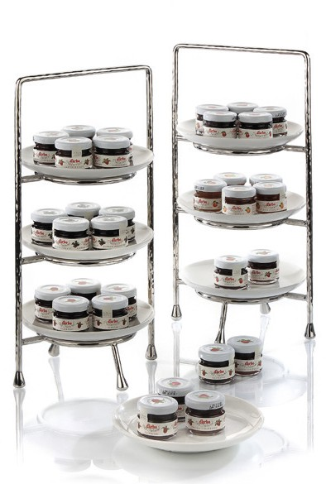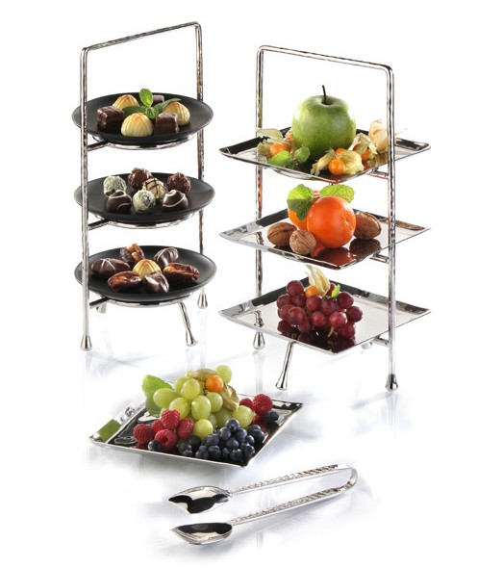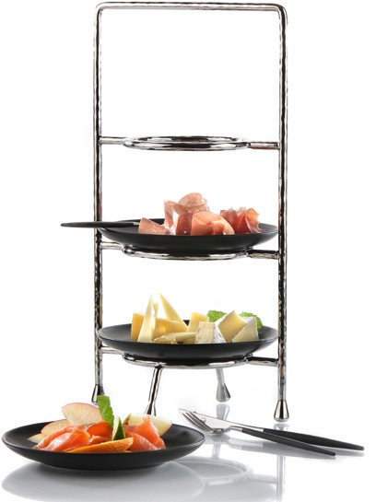Etageres by Zieher

Elegantly served and presented in style – classic plate etageres, newly interpreted!

Shapely and individual stands by Zieher are suitable for numerous applications. The classic plate etageres are available with three levels in two sizes.

Fitting numerous suitable inserts made of china, glass, or stainless steel allow sophisticated combinations of various materials and flexible setup designs. Petit fours, desserts, chocolates or other delicacies are effectively presented by the classic mini format etageres.

The larger versions are perfectly suitable for scones and jam during Five O‘Clock Tea, but also a choice of cold cuts, cheese or fruit can be staged elaborately on the set table.

WWW.ZIEHER.COM

03/2022
Zieher KG, Kulmbacher Straße 15, D - 95502 Himmelkron • marketing: +49 9273 9273-68 • presse@zieher.com
In our press area on www.zieher.com you will find all press releases including visual material to download.

