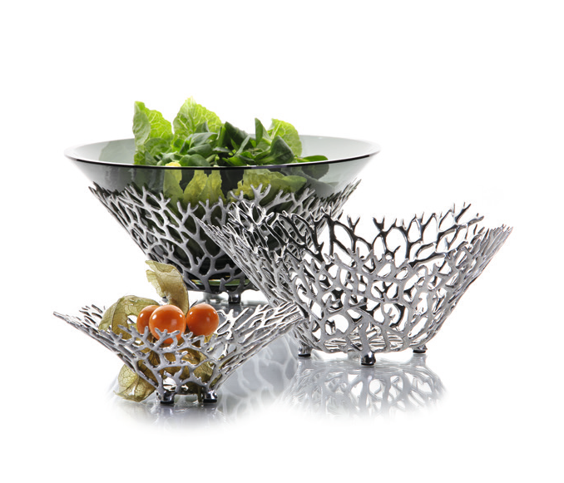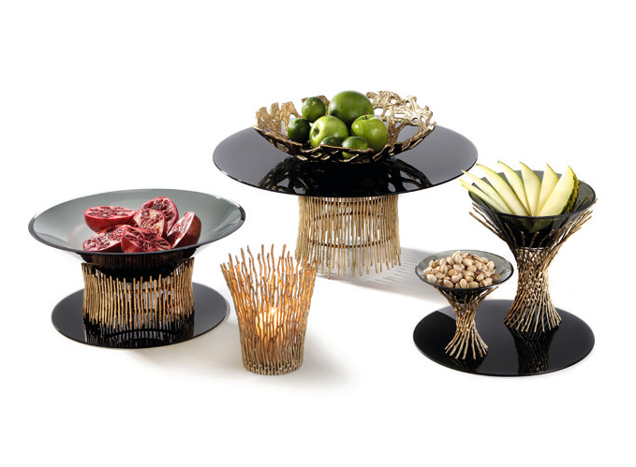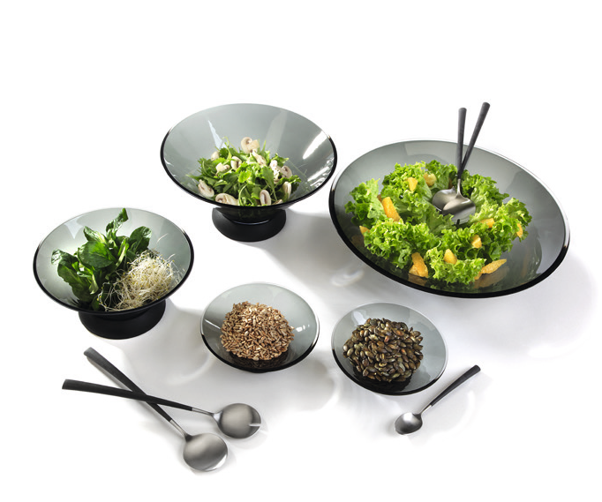Grey glass bowls

The handblown bowls made of grey-tinted glass are deliberately restrained in their design, yet they have have been shaped to exhibit high versatility in their appearance.

The combination of the bowls with the gold-coloured stands of the “Somnia” series creates an opulent and extravagant buffet staging which is fascinating purely by its appearance.

The subtle grey tinting of the glass bowls matches perfectly with the matt black or white surface of the optionally available silicone rings which form a non-slip basis and increase stability.

WWW.ZIEHER.COM

03/2022
Zieher KG, Kulmbacher Straße 15, D - 95502 Himmelkron • marketing: +49 9273 9273-68 • presse@zieher.com
In our press area on www.zieher.com you will find all press releases including visual material to download.

