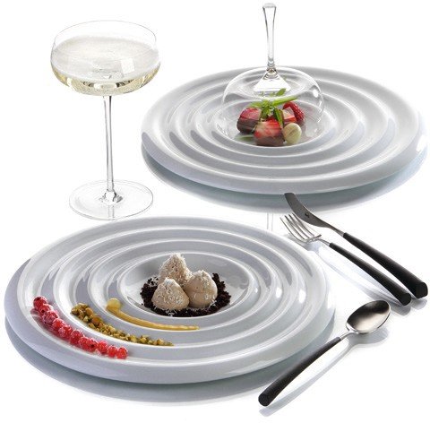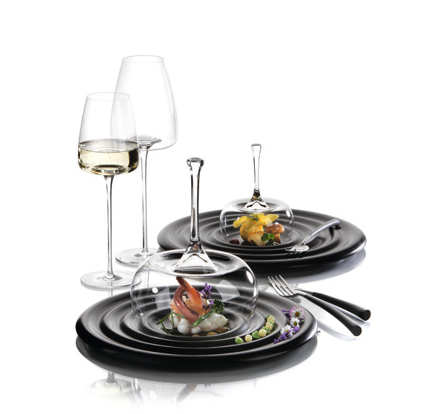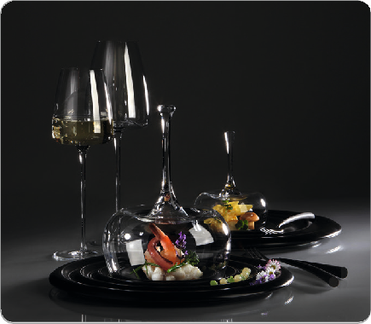„Pulsar“ – sparking impulses!

This gourmet plate, predestined for appetizers, intermediate courses or desserts, excels through its exceptional shape and thrills the beholder by the exotic touch it has been awarded by its Chinese designers. The surface is reminiscent of the playful waves created on a smooth lake after a stone’s throw.

The viewer’s gaze purposefully wanders to the centre of the concentric design and this way the served dishes come straight to the fore. Be it for selectively arranged sauces or dips, crunchy crisp caramelized nuts or edible flowers, even the wave troughs of the plate’s rim offer numerous possibilities to stage dishes effectively.

“Pulsar” is made of high-quality hard porcelain in a surprisingly soft composition and is available glazed in glossy white or in matt black.

Design: Grace Liu und Jian Ping Li

WWW.ZIEHER.COM

03/2022
Zieher KG, Kulmbacher Straße 15, D - 95502 Himmelkron • marketing: +49 9273 9273-68 • presse@zieher.com
In our press area on www.zieher.com you will find all press releases including visual material to download.

