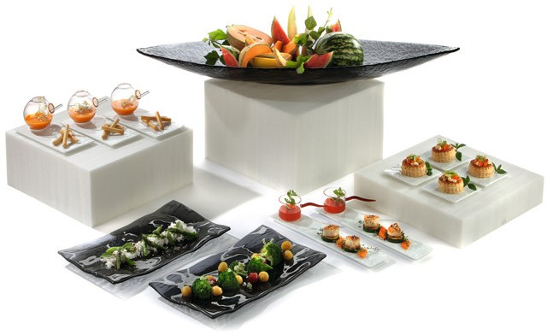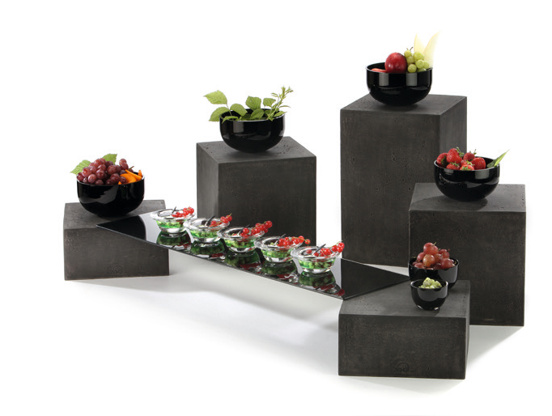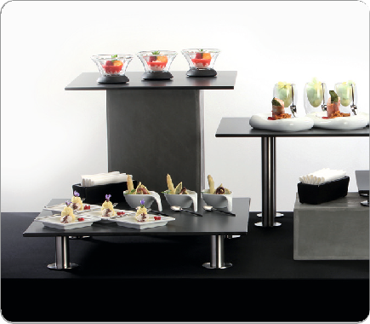Endless Combinations – The “Zieher-System”

Zieher offers innumerable possibilities to present food in a visually appealing and highly flexible way. When developing new buffet products it is of utmost importance for Zieher to guarantee compatibility among the individual systems.

The “Zieher-System” with its up to five standardised heights offers an optimal division of the buffet’s different presentation areas and thus makes arranging buffets highly flexible. Many options are available regarding design and material: the wide range consists of buffet elements made of stainless steel, laminated plastic, wood, clamshells, carbon, resin, concrete imitation and many more.

Because of the multiple possibilities concerning design and material, every buffet is easily adapted to any accommodation. The system becomes part of the whole arrangement and integrates harmonically into any ambiance. Play with a multitude of possibilities and surprise your guests with unique presentations!

WWW.ZIEHER.COM

03/2022
Zieher KG, Kulmbacher Straße 15, D - 95502 Himmelkron • marketing: +49 9273 9273-68 • presse@zieher.com
In our press area on www.zieher.com you will find all press releases including visual material to download.

