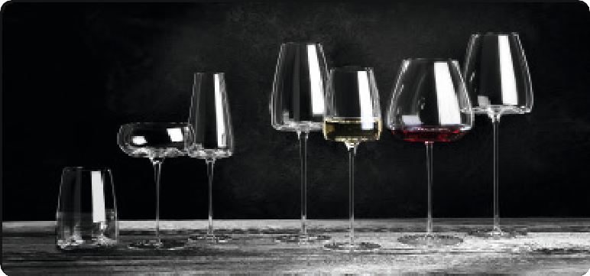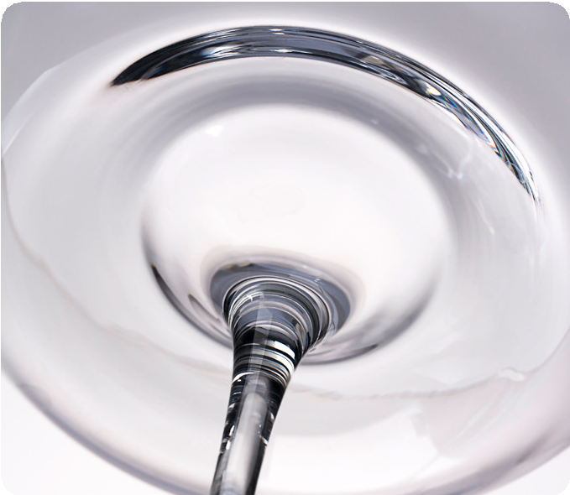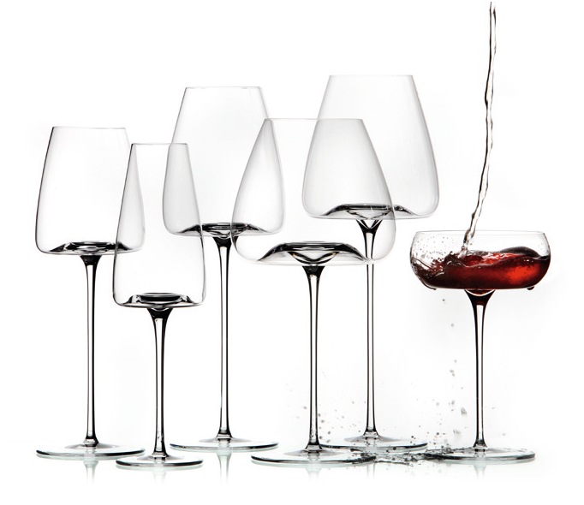„VISION“ – You have never seen wine like this!
Silvio Nitzsche - WEIN | KULTUR | BAR - Dresden

Filigree Craftsmanship meets Innovative Design
“Zieher glasses are all about top quality craftsmanship, which is crea- ted in one of the most innovative and best glass blowing workshops in the world. Each glass is unique, and has been created from lead- free crystalline glass using a traditional, hand-blown method.
As well as having a perfect, highly sophisticated and fascinating design, the glasses in the VISION range are guaranteed to provide maximum aroma and optimum development of the wine. However, it is particularly the fascination of the light, the colours and the visual depth that make it impossible to tear your eyes away from the glass, because: You have never seen wine like this!”

The Vision
“No distinction is made between red wine or white wine glasses in this collection, the glasses are simply theme-based or character- based. The names of the glasses (FRESH / STRAIGHT / INTENSE / BALANCED / RICH / NOSTALGIC / SIDE) clearly explain what they are used for: You intuitively reach for the glass which presents the flavours of the wine that you particularly wish to emphasise in the best way.
If you want a powerful wine to be more harmonious or a touch livelier and fresher, you pick the glass with the relevant designation.”
Silvio Nitzsche - WEIN | KULTUR | BAR - Dresden

The Zieher - Food-VISION
The series VISION is predestined for wine and has been created to perfectly represent its different facets.
In addition to this, the glasses offer an extraordinary platform for small delicacies or complimentary dishes from the chef. The har- monic wavy shape of the bottom creates an eye-catching ring when filled with spume or liquids. The depression in its centre provides space for Amuse Boúche or decorative highlights.

For further information about the VISION series, philosophy and far-reaching analysis of the sommelier Silvio Nitzsche please visit www.zieher.com/en/products/vision.html

WWW.ZIEHER.COM

09/2016
Zieher KG, Kulmbacher Straße 15, D - 95502 Himmelkron • marketing: +49 9273 9273-68 • presse@zieher.com
In our press area on www.zieher.com you will find all press releases including visual material to download.

