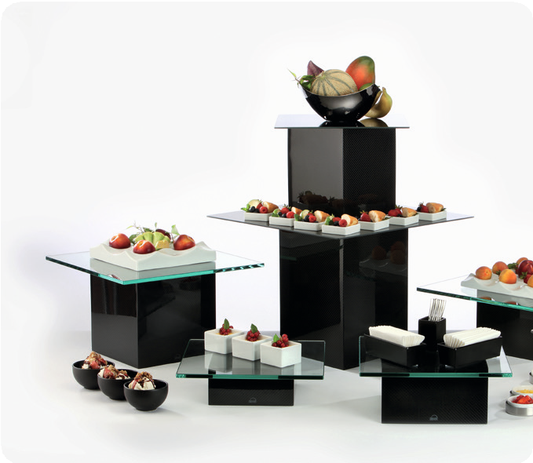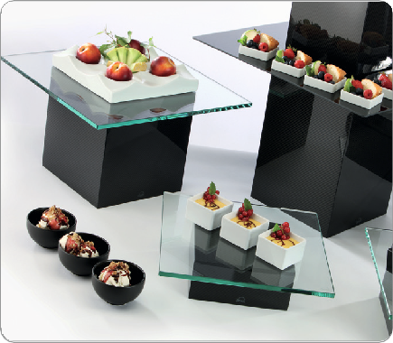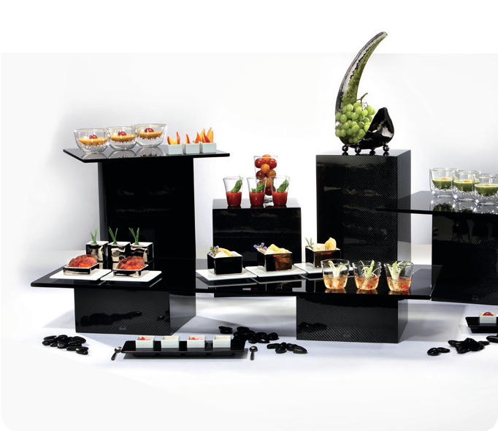“V12“ – Carbon on the Buffet!

The „V12“ buffet-displays by Zieher combine modern and reduced forms with the precious material carbon. Elegant optics coupled with small weight with maximum stability – “V12” takes high-tech to the buffet!

“V12” is combinable with many other Zieher buffet-systems. The typical Zieher height classification is 8,16 and 24cm (base 20x20cm) facilitates the simple combination with existing systems.

In combination with the enormous Zieher assortment of buffet- sheets, “V12” offers a maximum in flexibility and best usage of the buffet surfaces.

Carbon which is a carbon fiber tissue infused in synthetic resin originates from exclusively technical uses, for example racing and aerospace industry.

Apart from its technical aspects, carbon stands also out because of its extraordinary and three dimensional optics which makes the material more and more suitable for the design of products.

WWW.ZIEHER.COM

03/2022
Zieher KG, Kulmbacher Straße 15, D - 95502 Himmelkron • marketing: +49 9273 9273-68 • presse@zieher.com
In our press area on www.zieher.com you will find all press releases including visual material to download.

