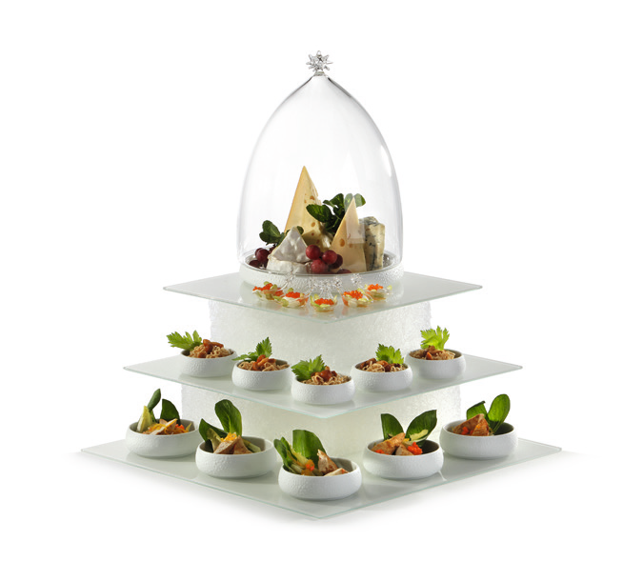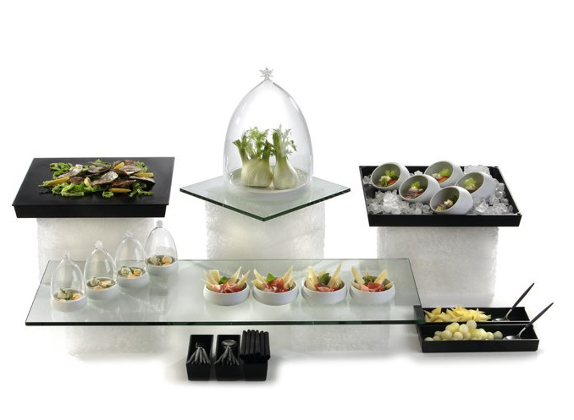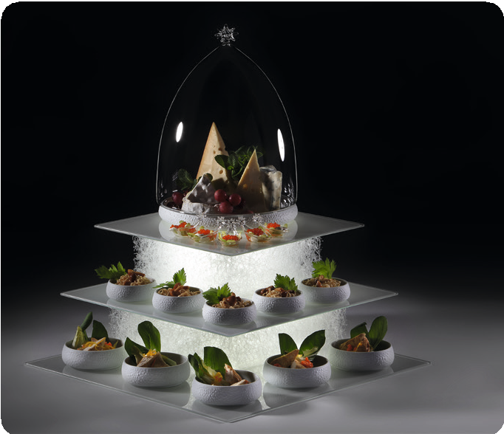“Textura“ – indestructible, innovative, exclusive!“

The exclusive cuboids of the „Textura“ series are exceedingly interesting, even at a second glance, due to their awesome structure. They consist of thin polyethylene filaments which are convoluted intricately and fused together. This awards them a flexible but nevertheless very stable texture.

The true potential of this innovative material is only disclosed in connection with light. The light-conducting properties of the filigree filaments manifest effectively when using the rechargeable Zieher LED light, which fits exactly into the cut-outs on the bottom side of the displays.

The “Textura” buffet cuboids are available in two sizes which, when used separately or stacked on top of each other, create different presentation levels on the buffet. Buffet platters and trays are reliably kept in position due to the non-slip features of this material.

“Textura” lives up to the high demands of gastronomy and catering in numerous ways. The displays are indestructible and very light,
washable and dirt-repellent. The countless interspaces create a light- flooded meshwork which dries very quickly and is therefore resistant to humidity and mold.

Also the raw material itself is something to be proud of. Polyethylene can repeatedly be 100% recycled without losing its outstanding characteristics. It is non-hazardous physiologically, odorless, tasteless and resistant to a variety of acids, oils and grease.

WWW.ZIEHER.COM

03/2022
Zieher KG, Kulmbacher Straße 15, D - 95502 Himmelkron • marketing: +49 9273 9273-68 • presse@zieher.com
In our press area on www.zieher.com you will find all press releases including visual material to download.

