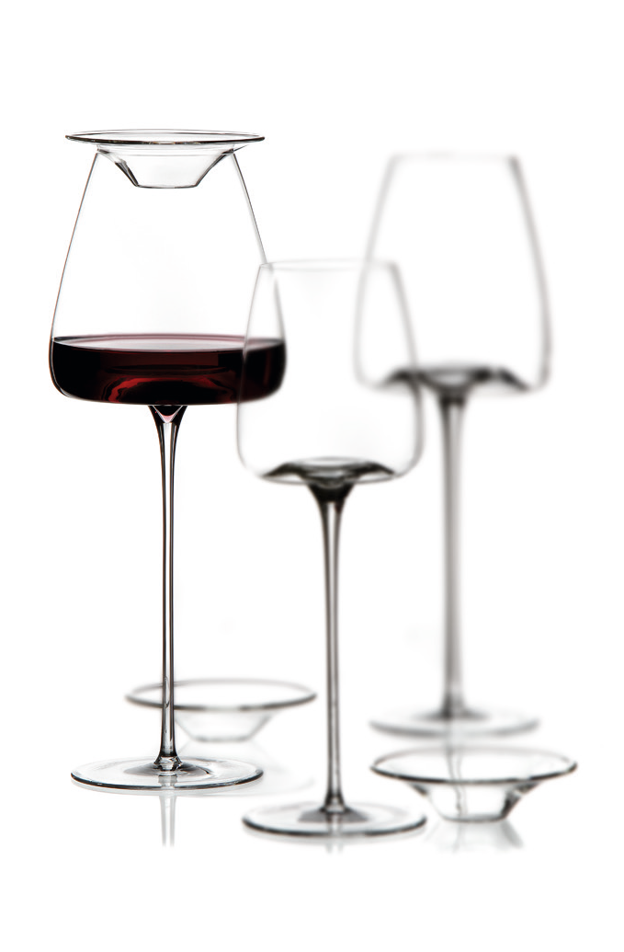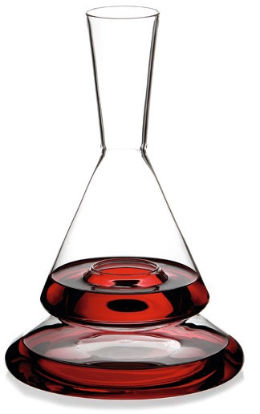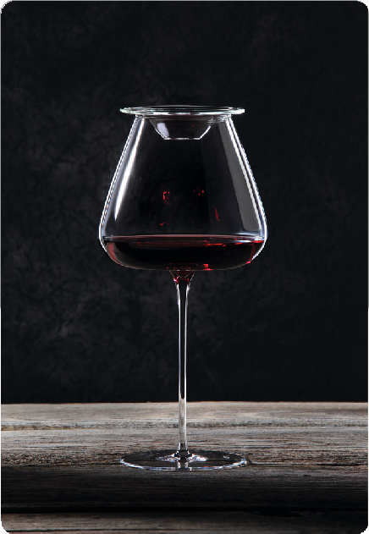
Covers fine wines, preserves volatile aromas and acts as a serving lid.

Silvio Nitzsche, WEIN|KULTUR|BAR Dresden

“It‘s not just a wine glass lid, it‘s about capturing transience. Hardly anything is as volatile as the wine aromas that escape from an open bottle or a filled wine glass. It happens automatically and
naturally. It is irreversible and, in retrospect, often leaves a feeling of regret for not being able to capture the moment.
Sometimes it‘s in fact the small and inconspicuous things that leave a particularly big and lasting impression - like the “Tesoro” wine glass lid. It creates wine experiences you have never before consciously and obviously perceived.“

The function:
Inside a wine glass, a microcosm of different aroma molecules is created. The variety of primary, secondary and tertiary fragrances emanates from a wine glass in several stages and cannot be enjoyed in interplay.
The “Tesoro” lid preserves the volatile aromas within the glass. The wine does not develop more slowly, but the fragrance molecules, which normally vanish, can be perceived gradually or together - at your own discretion. Thus the little enjoyment helper enables a com- pletely new wine experience.

Tapas culture:
Tapas (lit.: small lids) meanwhile have become a gastronomic con- cept. According to the actual literal origin, you can arrange accom- panying snacks and sweets on the „Tesoro“ and serve them to your guests with the wine glass.

The product:
The „Tesoro“ wine glass lid preserves the volatile aromas and fits on every VISION wine glass. At the same time, it protects the wine from flying insects and other foreign bodies.
The lids are made of high-quality borosilicate glass, which origina- tes from the laboratory sector and is known for excellent chemical resistance and high light transmission in combination with a flawless surface quality. The break-proof glass can easily be cleaned in the dishwasher and is odourless - the basic requirement for preserving the aromas of the wine.

WWW.ZIEHER.COM

Putting the rule to the test:
Take two glasses of the same kind. Now fill both of them equally.
„Seal“ one of the glasses with „Tesoro“ and leave the other one open. Wait for just five minutes and then smell both glasses.
Both wines will be identical in taste! This reflects the development passed through by the opened wine nevertheless. Note the variety of aromas, which you can absorb and analyse in the glass previously closed with the lid. You will be astonished” and will probably never want to enjoy a wine without „Tesoro“ again.

WWW.ZIEHER.COM

