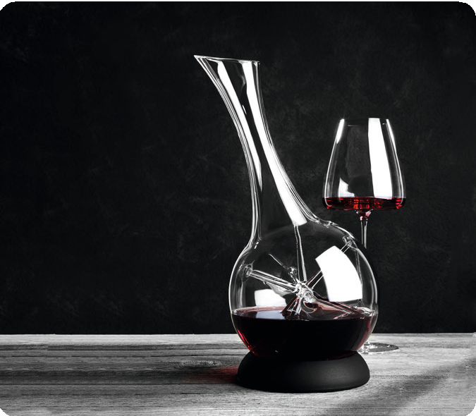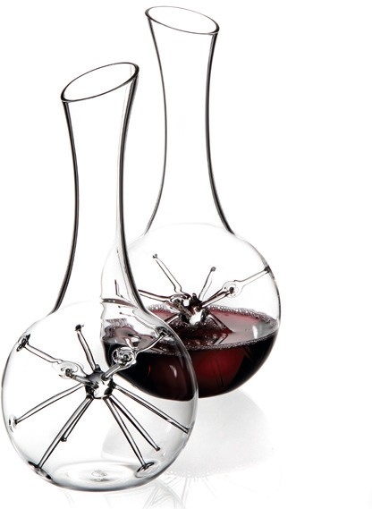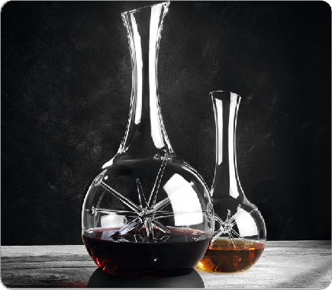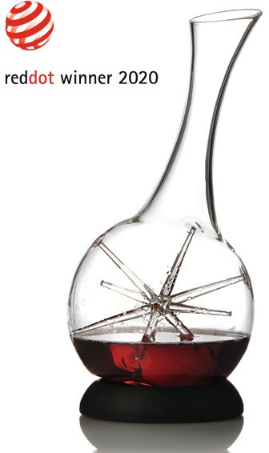
The decanter „Star“ synergizes the aesthetics of a unique copy with the functionality of a professional tool for vinophile pleasure. Based on products by glassblower Detlef Greiner-Perth and presented by Silvio Nitzsche “Star” is possibly the most fascinating wine carafe in a long time due to its exceptional design.

A masterpiece of craftsmanship is the star positioned inside the decanter. Besides the positive influence this object has on the development of the wine it attracts in an almost magical way the glances of the beholder. Thus “Star” moves into the center of attention and awards the enjoyment of wine at home but also the service in a restaurant a perceived value.

The individual star raises each carafe to a unique piece and thus creates a fascinating basis for conversation with interested guests. This artfully created centerpiece becomes an unique element in an excessively complex multi-stage process. This is pure luxury in our uniform world because not a single star is of the same kind.

„STAR“ - Mini
Due to its reduced size the small decanter is particularly suitable for the decantation of open wines or small bottles. The ideal charge to provide a maximum of oxygen is 0.375 ltr. Also for the staging of innovative high-end cocktails, flavoured spirits to the point of exotic juices this unique product is the perfect solution.

„STAR“
The big ”Star“ has a recessed grip at the bottom which improves the swirl during filling and slewing. On the other hand it guarantees a safe handling and firm stand while serving the wine. A black silicone collar enclosed in the present box offers an attractive base and allows inclined positioning of the decanter.

Uniqueness in practice
(Analysis by Sommeliers Silvio Nitzsche)
“Many decanters provide a fast but completely unbalanced development of wines because the wines develop only by a macro- oxidation at the surface. It`s more balanced and harmonic to implement the necessary oxygen in a very soft and gentle way. The filigree rays of the centric star animates the served wine to a very soft enhancement. During the slewing the oxygen is mildly folded in and integrated into the wine. Thus the wine starts to develop on its own terms and not – as with other decanters – just at the surface.

The swirling of the wine is a fascinating view and helps in a three- dimensional development to harmonize the acid and to synchronize different levels of aroma.

By using borosilicate glass as raw material for this decanter, which sticks out by its extremely smooth surface, another highly pleasant effect is, that the aromatic molecules aren`t expelled from the wine but allowed to present themselves completely in the wine glass. The aerated wine becomes extremely balanced, carefully crafted and centered. An additional value which is simply priceless !”

Silvio Nitzsche, WEIN/KULTUR/BAR Dresden

WWW.ZIEHER.COM

