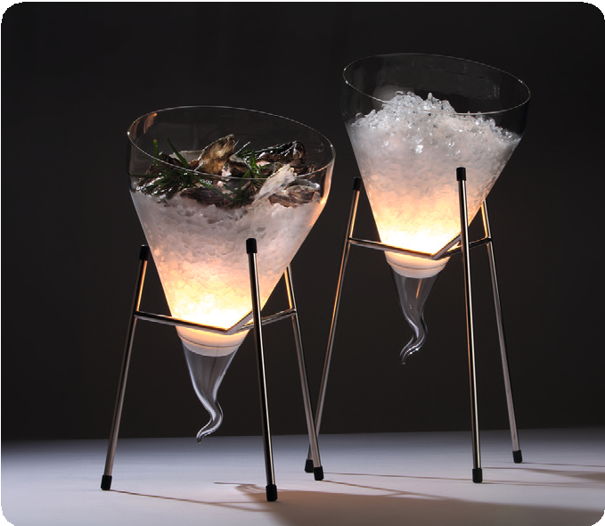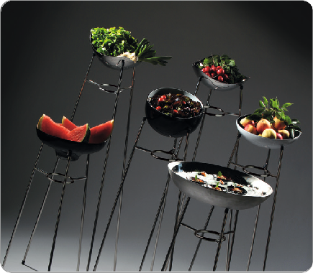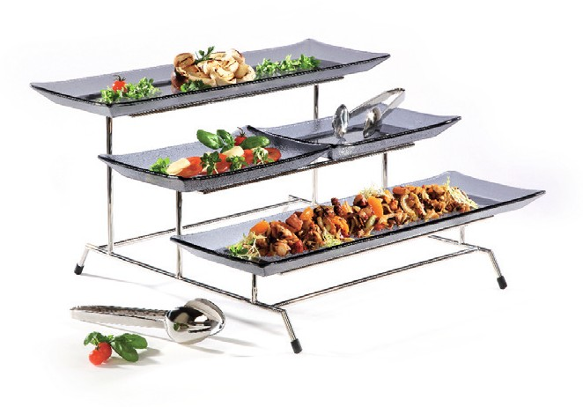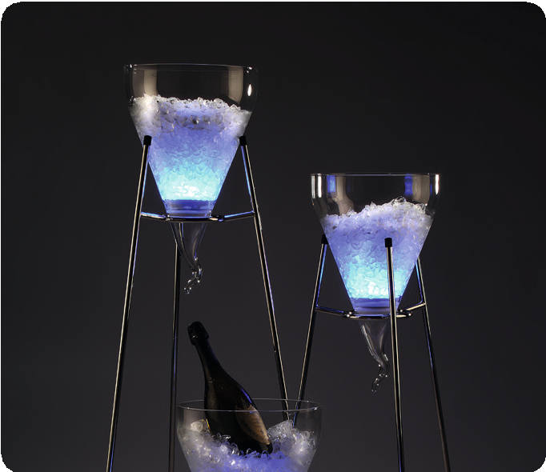„Stablo“ - filigree versatility

The buffet stands, made of solid stainless steel and polished to a high gloss, impress with their high-quality workmanship and graceful appearance. Bowls and plates seem almost floating. Non-slip caps on the feet guarantee a secure stand. The „Stablo“ XL stand can even be stretched to heights between 80 cm and 120 cm thanks
to suitable extensions. Massive and bulky buffet tables are almost superfluous!

The buffet stand with integrated ring allows, in addition to the placement of plates and plates, the inclusion of extraordinary wine coolers made of borosilicate glass. These can also be placed in the
„Stablo“ stands in sizes M and L if positioned at an angle.

The shape of the cooler made of borosilicate glass in a reinforced quality corresponds to the already known Zieher cloches ensures the necessary stability! Condensation running on the outside is passed through the mold in a controlled manner to the lower tip. Draining water can thus be collected by placing a small bowl on the floor or buffet table!

Optionally available Zieher cordless LED lights achieve a breathtaking look and put champagne, but also ice-cold food in the right light!

A three-tier buffet floor offers space for finger food of all kinds and can be equipped with numerous trays and plates from the Zieher range. Non-slip pads prevent disturbing noises and guarantee the secure hold of the trays.

WWW.ZIEHER.COM

03/2022
Zieher KG, Kulmbacher Straße 15, D - 95502 Himmelkron • marketing: +49 9273 9273-68 • presse@zieher.com
In our press area on www.zieher.com you will find all press releases including visual material to download.

