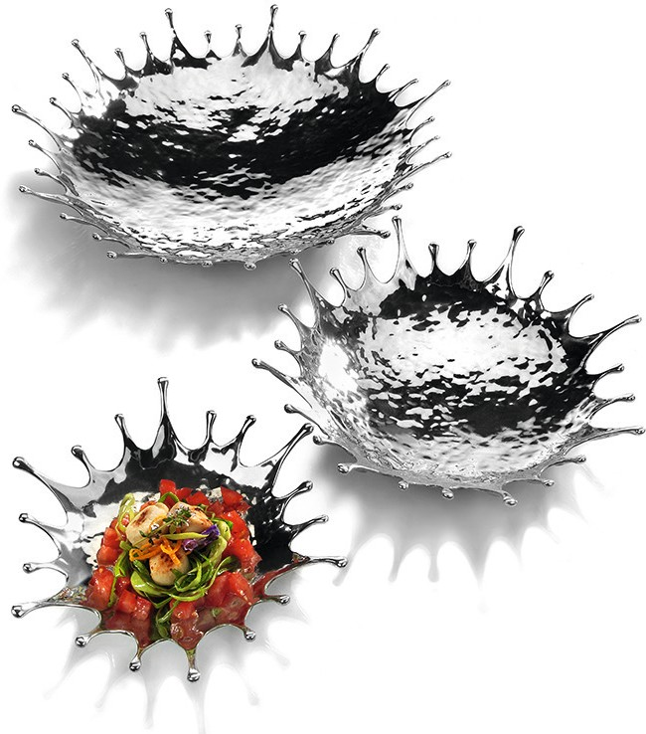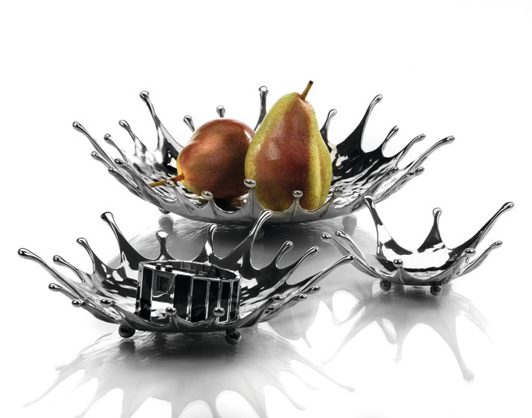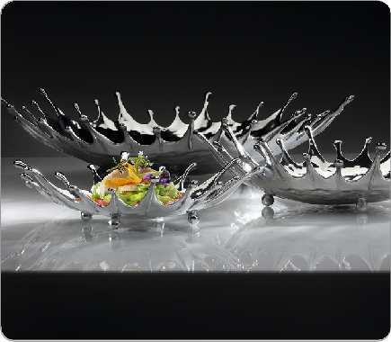The “Splash“ – effect

Dynamics of movement – solidified to a statue ! The bowls of the “Splash” series spread a very special flair by their playful optics!

Whether used as fruit bowl in the big, for Amuse gueule / culinary delights in the small or as decorative deposit place in all varieties, “Splash” sets a charming course at the table and for interiors.

The bowls are made of solid pewter alloy, manually assembled of numerous single components and elaborately refined. Knobbed feet at the bottom side guarantee a safe stand.

WWW.ZIEHER.COM

03/2022
Zieher KG, Kulmbacher Straße 15, D - 95502 Himmelkron • marketing: +49 9273 9273-68 • presse@zieher.com
In our press area on www.zieher.com you will find all press releases including visual material to download.

