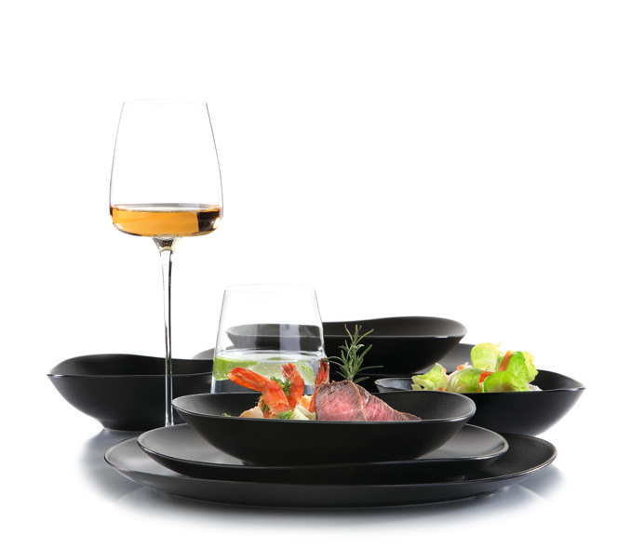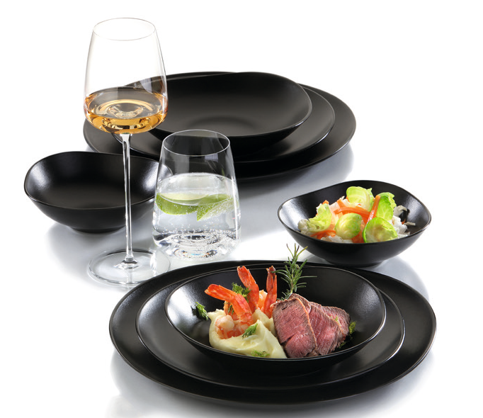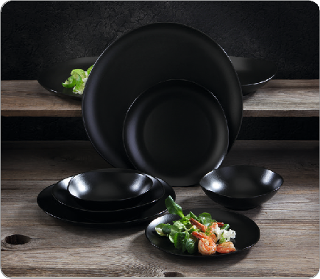“Sombre” - dark accents!

The “Sombre” series combines the robustness of porcelain with the
individual charm of unique pieces made of ceramic.

The deep dark hue of the matt glaze deliberately focuses on subtle irregularities and puts the served dishes into the centre of
attention. The organic shape creates a subtle tension. It fits into any environment without losing its individuality.

In combination with other series and materials, it becomes possible to set new accents ever and anon.

Particularly resistant hard-paste porcelain enables the production of comparatively thin and filigree parts, which are provided with an intensely matt black glaze. The five-part small series consists of three flat and one deep plate as well as a bowl for side dishes or salads.

WWW.ZIEHER.COM

03/2022
Zieher KG, Kulmbacher Straße 15, D - 95502 Himmelkron • marketing: +49 9273 9273-68 • presse@zieher.com
In our press area on www.zieher.com you will find all press releases including visual material to download.

