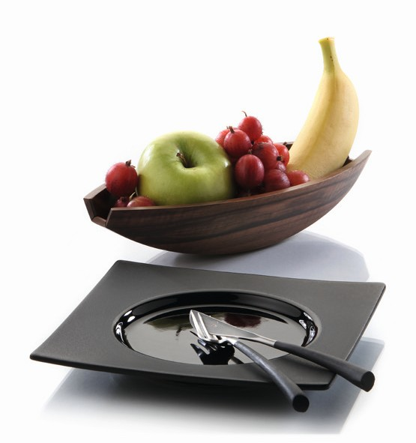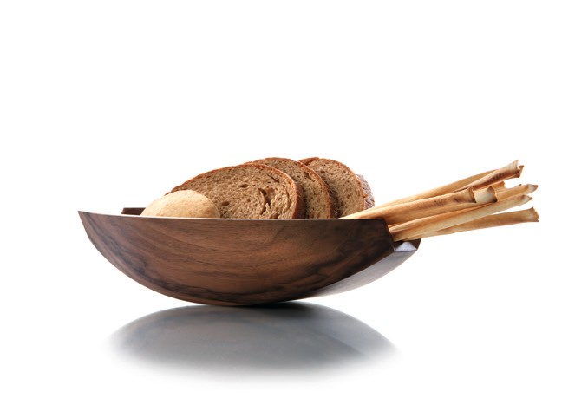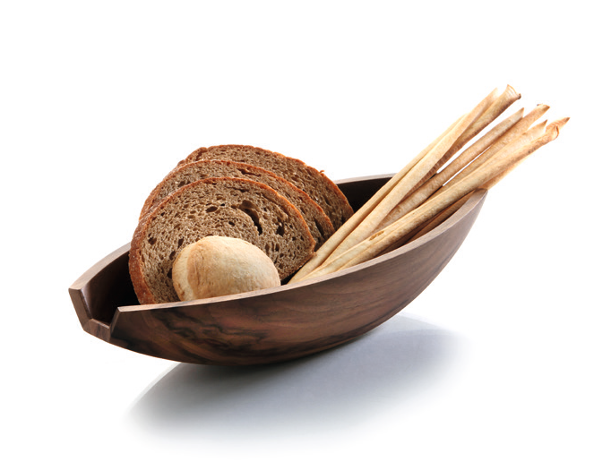Bread and Fruit – Stylishly Presented by „Solid“!

The bread baskets made of solid walnut wood surprise with their exceptional design and their highly sophisticated handicraft.
Designing these bowls, the Milanese designer Itamar Harari did not only think of serving bread, but also of the typical Italian Grissini.
Recesses at both ends are especially suitable for those. A selection of fruit in the hotel room also receives much attention if stylishly presented in these extraordinary bowls made of beautiful wood.

Manual workmanship of the highest level combined with a foodsafe sealing guarantee a long service life, even if used on a daily basis.

Design: Itamar Harari

WWW.ZIEHER.COM

03/2022
Zieher KG, Kulmbacher Straße 15, D - 95502 Himmelkron • marketing: +49 9273 9273-68 • presse@zieher.com
In our press area on www.zieher.com you will find all press releases including visual material to download.

