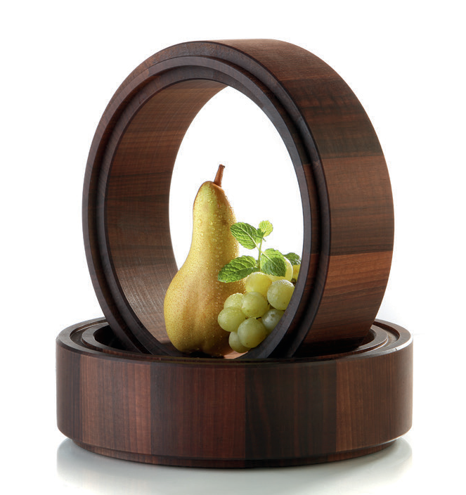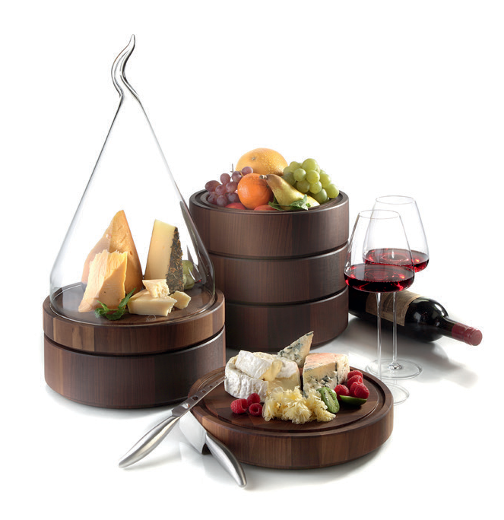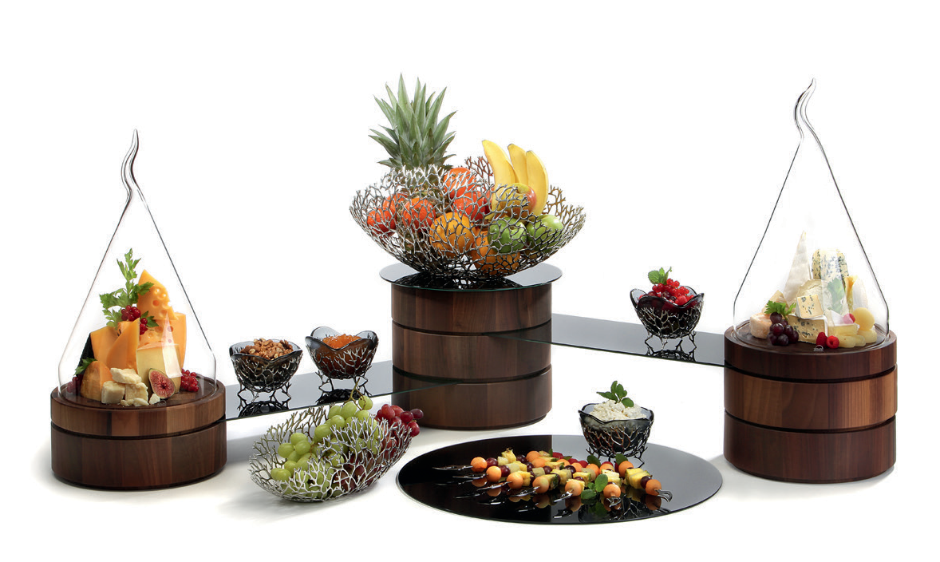 “Solid” - Cheese raised to the power of three

The high-quality cutting board made of fine end grain walnut wood is much more than a shapely and elegant kitchen aid. This product only unfolds its full potential in connection with the belonging stacking rings and bowls. All parts have a groove at the top, which allows quick and easy stacking of the various items, even in mixed arrangement.

The milled groove of the cutting board on the one hand serves as a juice groove and on the other hand as a receptacle for various glass cloches. Thus aromatic types of cheese can be presented. A classic cloche made of hand-blown glass or an extravagant organically shaped cover made from highly durable borosilicate glass protects and stages the food at the same time.

The stacking ring creates different levels of presentation when used in a clustered arrangement of cutting boards and trays. Also, the capacity of the bowls can be increased so as to present, for example, long baguettes.

Accurately fitting connection plates made of hardened, white or black coloured glass, can be slid exactly into the grooves of the stacked rings and thus work as buffet platters between the columns. This creates additional space and raises the flexibility of this system at the same time. Additional sizes of these plates, made of the same type of glass, offer a nice supplementation and allow an optically balanced buffet presentation.

The system blends harmoniously into the walnut wood series Solid. Using further sizes of the glass cloches on the buffet allows for impressive arrangements.

Cutting board, ring and bowl are sealed with high quality oils. Especially regarding the cutting board, this enables the simple refurbishment of the surface from traces of daily wear and tear.

More information: WWW.ZIEHER.COM

03/2020
Zieher KG, Kulmbacher Straße 15, D - 95502 Himmelkron • marketing: +49 9273 9273-68 • presse@zieher.com
In our press area on www.zieher.com you will find all press releases including visual material to download.

