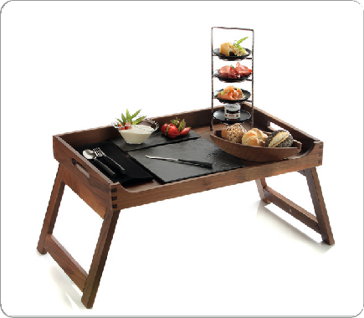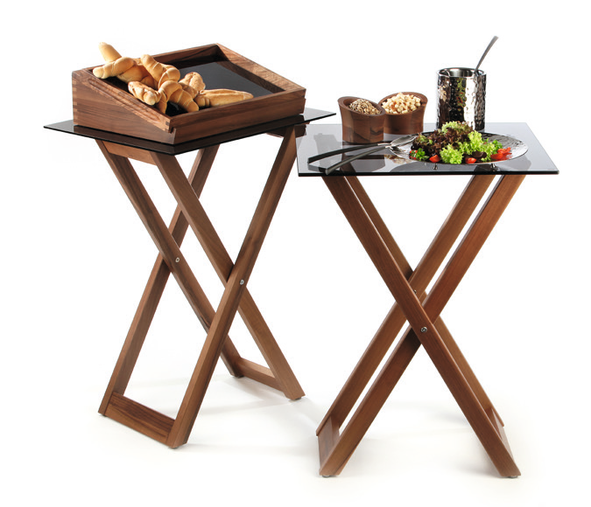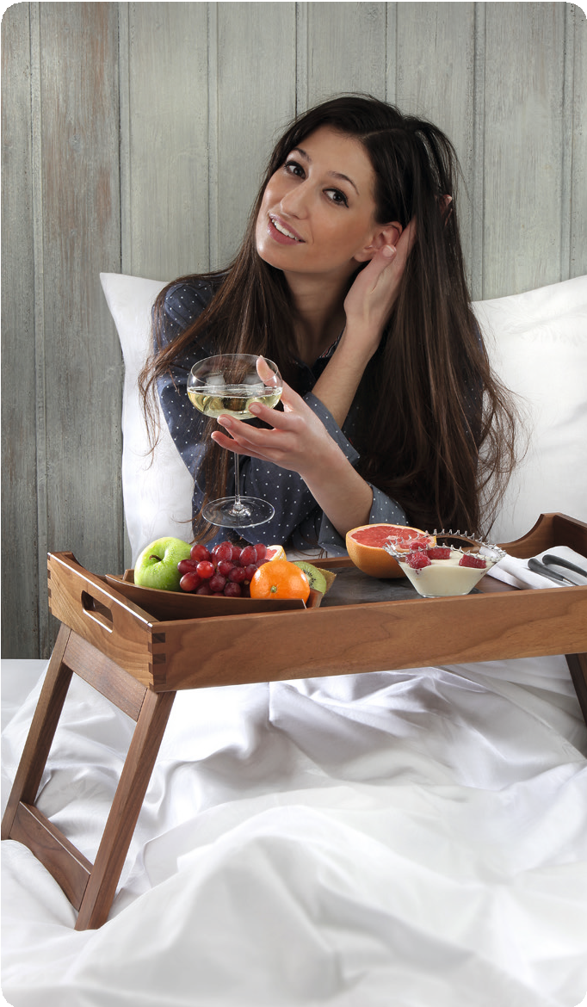Breakfast in bed – Dinner in your room!

The roomservice tray as well as the new bed tray stand out due to the precious walnut which is incorporated into these products with high-quality craftsmanship. The recessed longside enables
comfortable dining directly off the tray. The retractable feet of the bed tray have been constructed in a very stable way and are securely kept in position by integrated magnets when folded in.
The height of the erected tray has been chosen in a way that even with soft mattresses a comfortable seating beneath the tray is guaranteed. So start off the day with a boundlessly relaxing breakfast in bed!

The tray also cuts a good figure on the buffet. The positioning feet make it possible to dispense with the use of displays for heightened placing. A speedy set-up and flexible handling facilitate daily operations.

The also available shapely stand always provides the appropriate possibility to set up the “Solid“ room service tray in the hotel room but also in the restaurant. Combined with Zieher buffet platters in the format 2/1 GN, the stand easily and flexibly creates new spaces at a comfortable height. It is predestined for the use at the buffet as well as for the use during coffee breaks in the congress and convention business. The massive frame made of walnut wood harmonizes perfectly with other buffet items of the series “Solid” and “Mercato” and can be combined with them very well. Anti-slip rubber feet on the top prevent the shifting of platters and trays, felt gliders at the base protect the parquet flooring and ensure safe standing.

WWW.ZIEHER.COM

03/2022
Zieher KG, Kulmbacher Straße 15, D - 95502 Himmelkron • marketing: +49 9273 9273-68 • presse@zieher.com
In our press area on www.zieher.com you will find all press releases including visual material to download.

