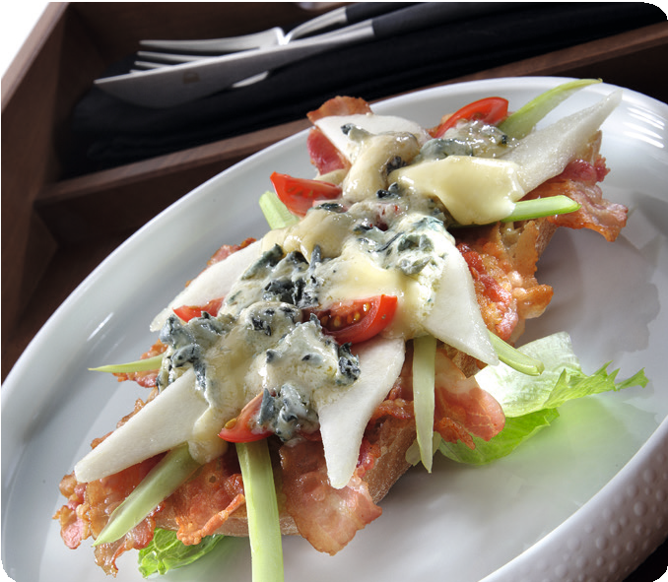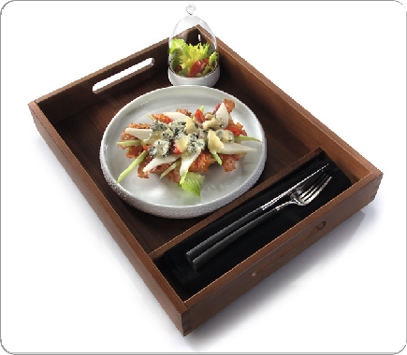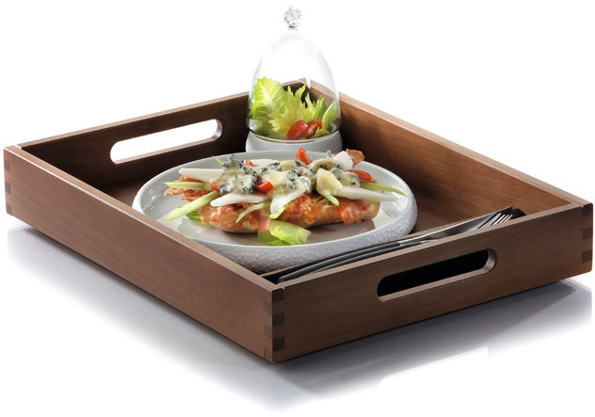Service tray “Solid“

This This service tray with integrated separations is perfectly suitable for the service of small dishes at the pool, the beach or in the room.

The major compartment has been designed for plates with a max. diameter of up to 29 cm, the lateral separation offers sufficient space for cutlery and napkin. Also insertion bowls with a max. width of 7.5 cm find space and thus can be used for dips, salad and other side dishes.

The trays are equipped with integrated grip holes and they are stackable. Finger joints at the corners, non-skid rubber feet and a food-safe sealing of the solid walnut wood fulfill the high quality standards which are valid for all items of the “Solid” range.

WWW.ZIEHER.COM

03/2022
Zieher KG, Kulmbacher Straße 15, D - 95502 Himmelkron • marketing: +49 9273 9273-68 • presse@zieher.com
In our press area on www.zieher.com you will find all press releases including visual material to download.

