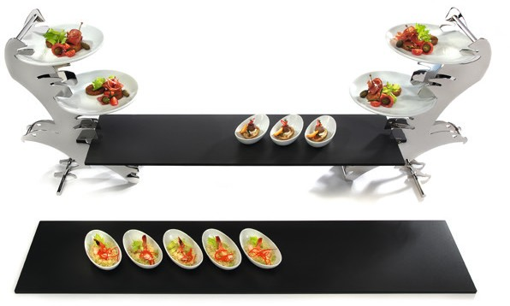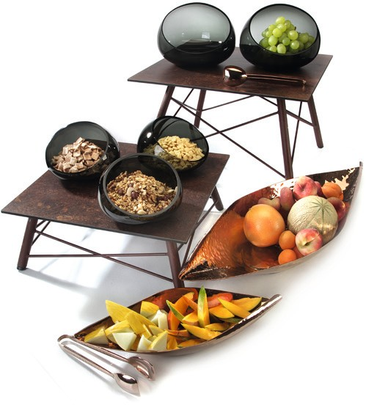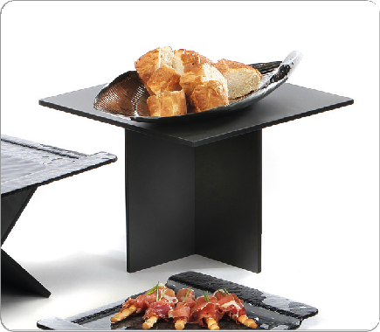The charm of transience

Break- and scratch-resistant, anti-static and dishwasher-safe - these features of laminated plastic platters and the resulting advantages are convincing!

The buffet platters made of laminated plastic are available in two neutral versions as well as in an extraordinary variation.

Unplastered brick-lined walls, load-bearing structural elements made of steel beams, exposed concrete and the morbid charms of abandoned factory buildings create the ambience for the rust- coloured decoration “Industry 2.0”. This is evocative of weathered steel surfaces, which are marked by decades of corrosion and fits perfectly into the industrial style of modern architecture.

All laminated buffet platters by Zieher have a dark middle layer and can be used on both sides because of their double-coating.

WWW.ZIEHER.COM

03/2022
Zieher KG, Kulmbacher Straße 15, D - 95502 Himmelkron • marketing: +49 9273 9273-68 • presse@zieher.com
In our press area on www.zieher.com you will find all press releases including visual material to download.

