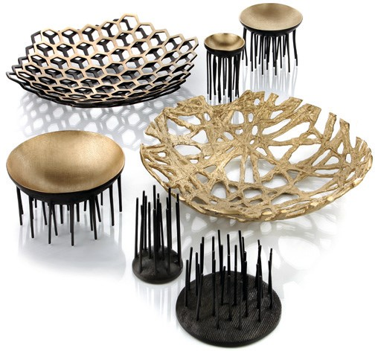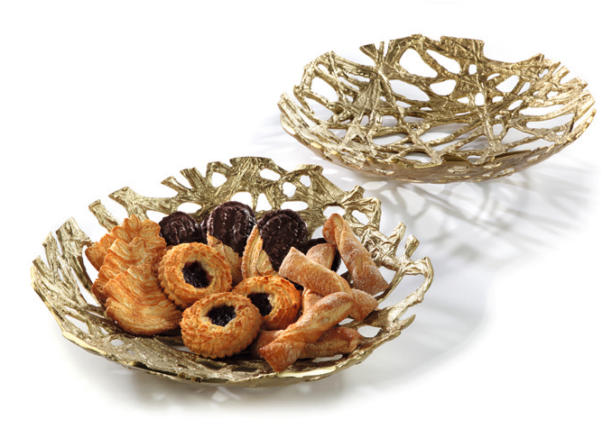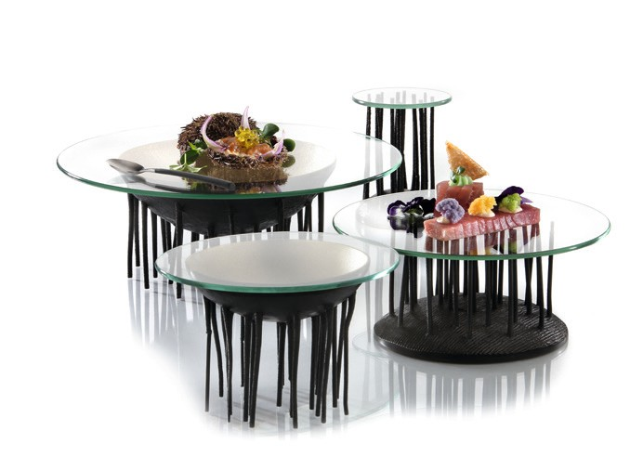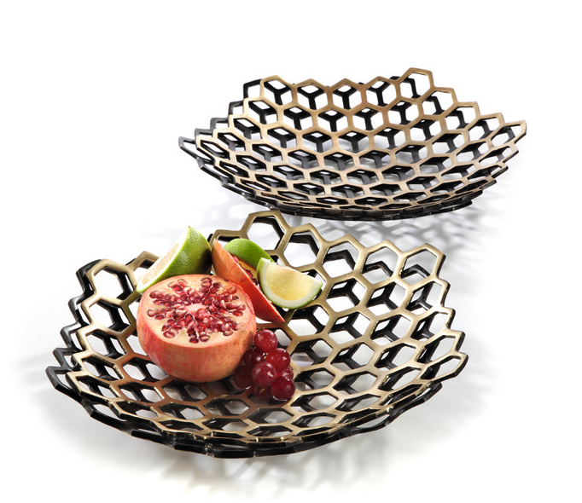“Roots”, “Matrix” & “Fakir” – brass all of a piece!

Massive brass is the raw material these items are made of.

Produced in traditional sand casting unique sculptural items are created, which enthuse especially by their contrast between matt golden surfaces and dark patination.

Opposing in form and shape but still belonging together these bowls “Roots” and “Matrix” as well as the exceptional displays of the “Fakir” series add up to a harmonic overall composition.

The bowl “Roots”, a tight web of rootlike structures, and “Matrix“, strictly geometrically constructed of hexagons, could hardly be more opposing. Especially this aspect makes the combination of the two so interesting. Besides the presentation of bread and fruit on the buffet these bowls fascinate as sculptures, too.

A perfect add on to the “Fakir“ bowls are round glass platters of the Zieher product range. These can be laid on easily and generate thus the option to use the impressive objects on both sides.

All items are golden-coloured and partially dark patinated, further discolouration or oxidation is prevented reliably by the food-safe sealing of the golden parts.

WWW.ZIEHER.COM

03/2022
Zieher KG, Kulmbacher Straße 15, D - 95502 Himmelkron • marketing: +49 9273 9273-68 • presse@zieher.com
In our press area on www.zieher.com you will find all press releases including visual material to download.

