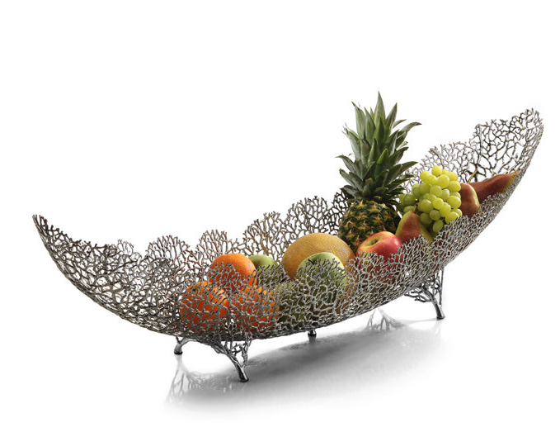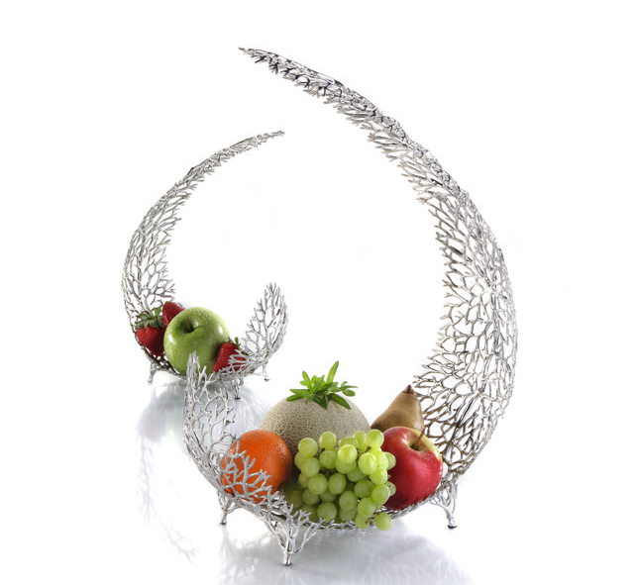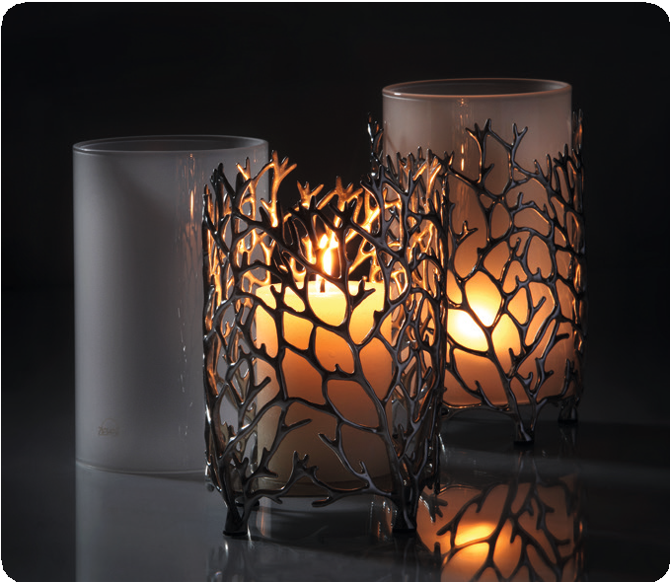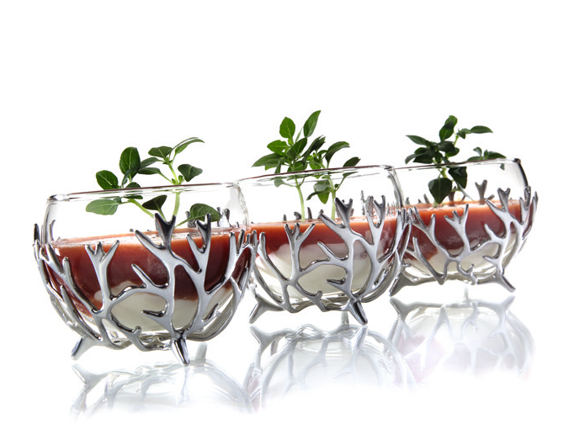“Reef“

The products of the “Reef” series are genuine gems of dining culture! Whether it is bowls filled with bread or fruit at the centre of attention or high-quality textiles held together by extravagant napkin rings emphasizing the ambiance, or the delightful shadow play of the candle light creating an atmospheric ambiance – “Reef” turns any table into a banquet.

Used as storage space for jewelry or standing on its own as a decorative sculpture, even off the table the bowls find their application.

Large numbers of single parts are casted from premium tin alloy and subsequently assembled in high-grade craftsmanship to give shape to these items. The inimitable pieces of art created that way
are unique items which inspire by the polished surface of the organic structures thus creating truly exceptional pieces of art that are reminiscent of deep sea coral reefs.

The outside texture of the bowls differs within the series: whether smoothly rounded or roughly structured with dark, patinized deepenings, each variant has its own charm!

The exclusivity of the gold-plated variation (18 k) is hardly to compete and sets luxurious accents at the artful set table.

The wind-light fascinates by reflections of the candlelight in the silvery metal and the dancing shadows of the slender structures. A removable cylinder made of heat resistant glass protects the flame from wind and thus allows the usage in the garden and on the terrace.

WWW.ZIEHER.COM

03/2022
Zieher KG, Kulmbacher Straße 15, D - 95502 Himmelkron • marketing: +49 9273 9273-68 • presse@zieher.com
In our press area on www.zieher.com you will find all press releases including visual material to download.

