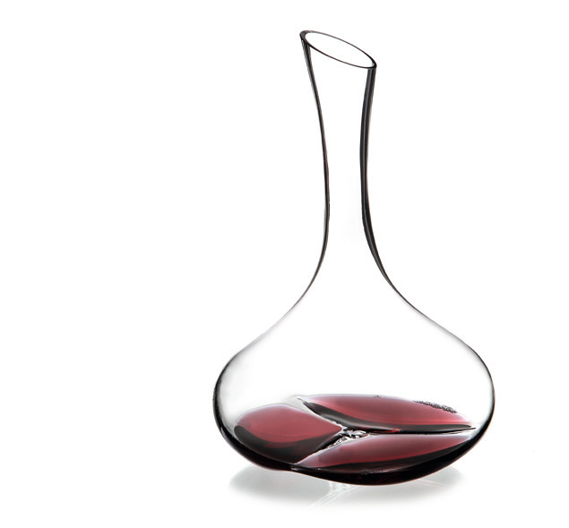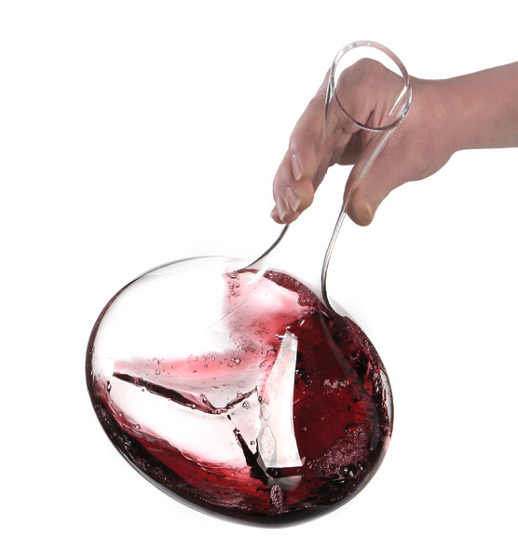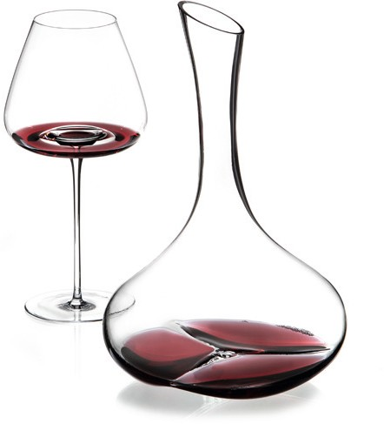Decanter “Pebble“

“Pebble” is made of high-grade, lead free crystal glass. The unfilled decanter inspires by the brilliance of the glass alone and the resulting light reflections. These products are hand-blown with perfect craftsmanship. The sensitivity and long-year experience of the glass blowers become apparent in particular in the creation of the bottom, which is extensively dimensioned and separated into three convex segments.

While filling the decanter the wine flows, due to the shaping of the neck, along the complete inside area, which maximises the surface of the wine and thus contributes to the aeration.The three swales at the bottom serve to further swirl the poured wine, which results in
a gentle but nevertheless very effective aeration. This effect can be intensified by warily swinging the filled decanter. Furthermore, the three bulges at the bottom provide a wiggle-free and safe stand. The diagonal cut of the neck and the accurate polishing of the raw edges minimise the formation of drops while pouring out. The optionally available drying rack made of solid stainless steel, facilitates the drying of the decanters after rinsing. Non-skid rubber caps ensure a safe stand.

Design: Itamar Harari

WWW.ZIEHER.COM

03/2022
Zieher KG, Kulmbacher Straße 15, D - 95502 Himmelkron • marketing: +49 9273 9273-68 • presse@zieher.com
In our press area on www.zieher.com you will find all press releases including visual material to download.

