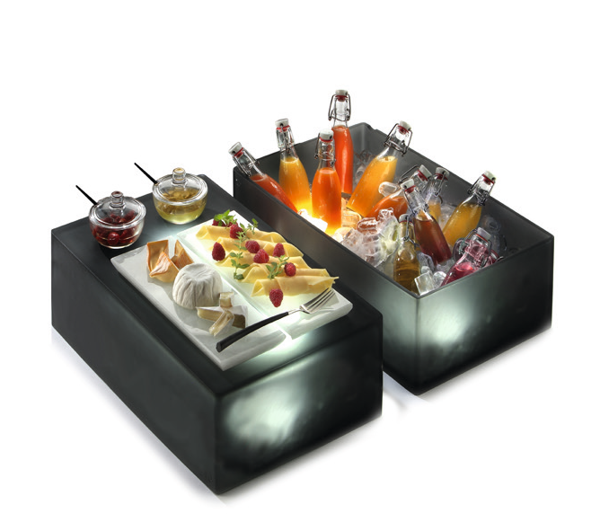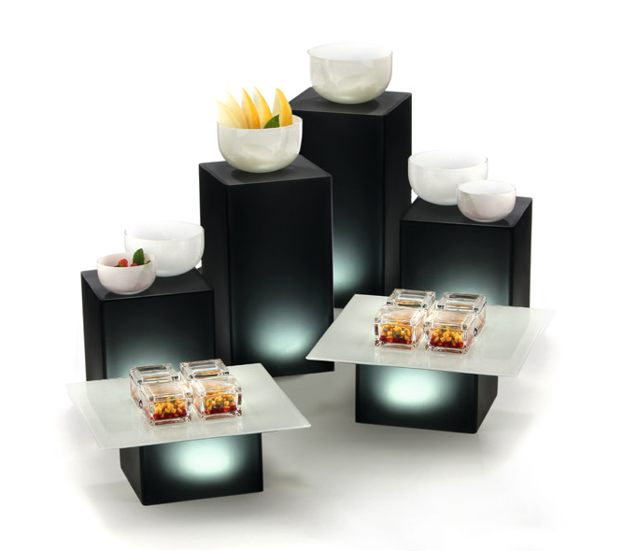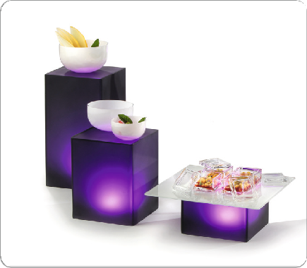„Neo“ – Dark elegance!

The buffet system „Neo“ is made of anthracite coloured resin. The matt surfaces and softly rounded edges of these translucent cuboids appear unobtrusive and modern.

The columns of this series are available in two different basic sizes and – depending on the model – in the heights of 8, 16 and 24 cm, as well as 12, 24 and 36 cm. This fits perfectly into the ZIEHER system and allows combinations with several other ZIEHER buffet systems. Two supplementary basins in 1/1 GN dimensions can be used to present iced food and drinks. These basins can also be used as displays with the closed side facing upwards.

“Neo” unfolds its true potential if the columns are effectively illuminated. The optionally available ZIEHER LED-lights – alternatively rechargeable or cabled – are the ideal completion to put “Neo” into its true light. By using the waterproof (up to 1 m) and remote-controlled rechargeable LED-Lights by ZIEHER it is also possible to illuminate the ice in the containers from below – a really fascinating view!

A big choice of LED-light colors guarantees spectacular effects!
A wine cooler resp. cloche made of the same material is a beautiful complement and blends harmonically into the system.

WWW.ZIEHER.COM

03/2022
Zieher KG, Kulmbacher Straße 15, D - 95502 Himmelkron • marketing: +49 9273 9273-68 • presse@zieher.com
In our press area on www.zieher.com you will find all press releases including visual material to download.

