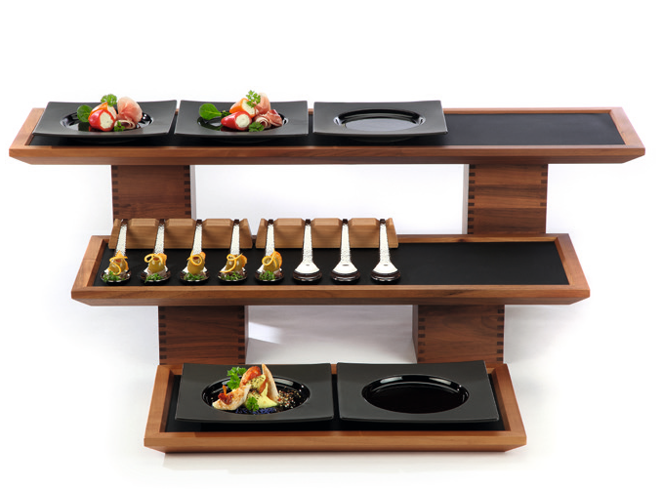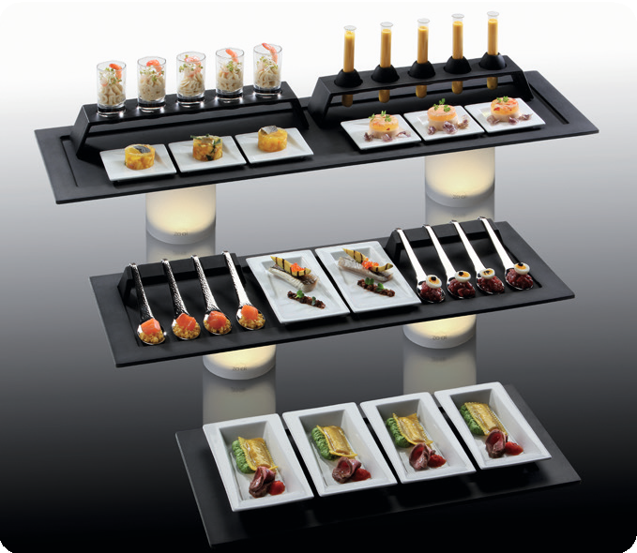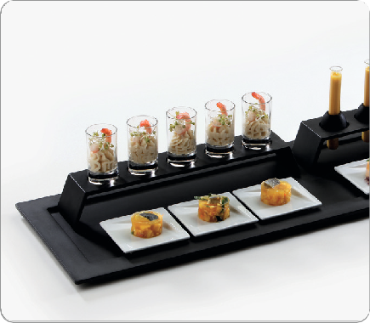“Modul”

“Modul“ is a flexible product ready for “Flying Buffet“ service - and therefore ideally suited for use in the catering area. The slim, oblong format of the base tray, which is available in three sizes, renders the often cumbersome service at crowded standing receptions barrier- free and uncomplicated. The trays can be variably fitted with glass or porcelain parts, a bridge for glasses or a spoon bench for 4 spoons. When using two spoon benches, 4 long skewers can be placed safely on top.

Every single piece has been specially developed for this catering system. Trays, bridge and spoon rest are available in 2 variations: The series “Modul“ is manufactured from solid walnut wood and from melamine in a modern matt-black design. Suitable miniatures made of china and glass can be fitted to all trays! Shapely anti-slip mats made of silicone facilitate catering to a great extent.

WWW.ZIEHER.COM

03/2022
Zieher KG, Kulmbacher Straße 15, D - 95502 Himmelkron • marketing: +49 9273 9273-68 • presse@zieher.com
In our press area on www.zieher.com you will find all press releases including visual material to download.

