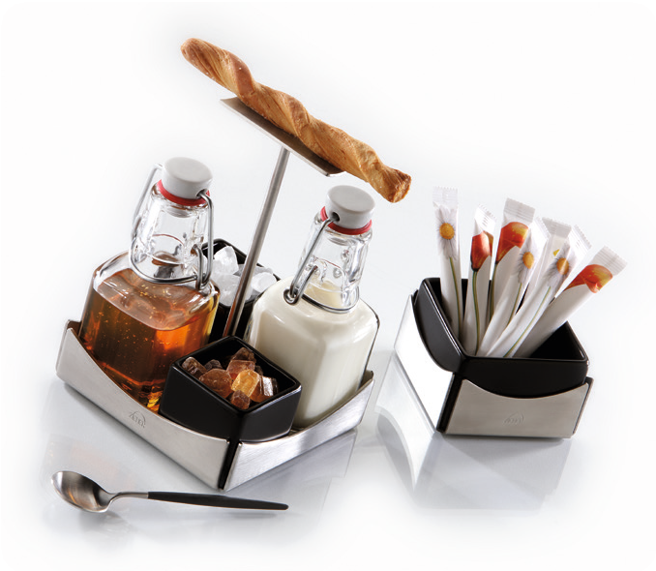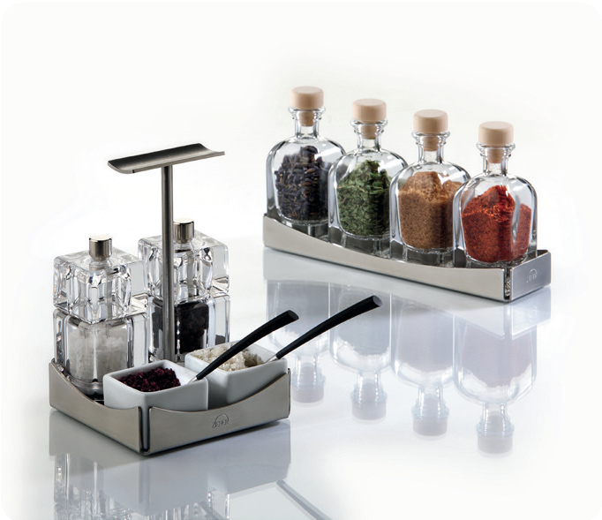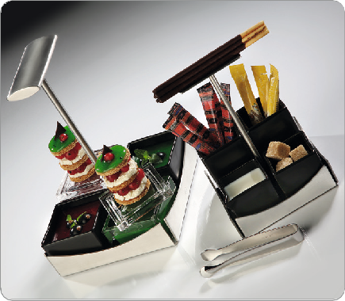Stainless Steel Ménage

The creativity and desires of high class catering have been implemented in the series of stainless steel ménages with fitting inputs.

This ménage is designed by Zieher and is available in three sizes (9,4cmx9,4cm, 11,4cmx11,4cm and 15,4cmx15,4cm). The additional small bowl and a long tray complete the product line.

Particularly important is that Zieher comes up with a great number of suggestions and suitable parts for equipping the stainless steel products. Small bowls and pourers made of glass and porcelain
in black, white or in platinum, acrylic mills (for different varieties of salt and pepper), glass bottles in different sizes (for oils, herbs, or dressings) and fitting inputs for any dish, ambience and concept. There are no boundaries in imagination and possible uses of this line for creative caterers.

The ménages stand out especially due to their heavy quality, elegant optics and easy handling when used in service. With Amuse Gueule/ Amuse Bouche playing a more and more important role, Zieher’s ménages are absolutely modern and trendy.

WWW.ZIEHER.COM

03/2022
Zieher KG, Kulmbacher Straße 15, D - 95502 Himmelkron • marketing: +49 9273 9273-68 • presse@zieher.com
In our press area on www.zieher.com you will find all press releases including visual material to download.

