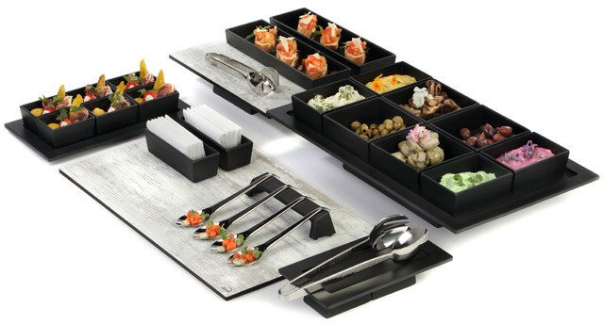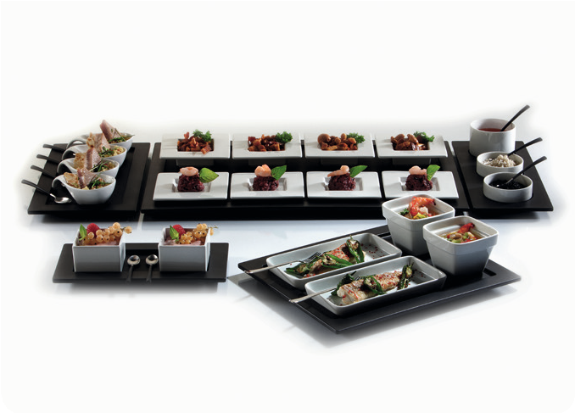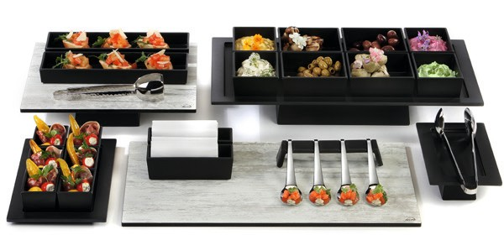Robust and elegant – Melamine!

Especially in daily catering operation, two advantages of the robust material melamine become evident: dishwasher and food safety.
The matt black surface of Zieher melamine products creates a clear contrast to glass and porcelain and impresses with its pleasant haptics.

The trays are available in regular GN sizes as well as in three slim rectangular formats. Due to their modern shaping and simple language of design, they blend well with the articles of the „Modul“ series and can extend the latter in style. The bridges and spoons rests can be used on all trays, non-slip feet on the undersides facilitate the service enormously.

Real added value is provided by different boxes made from the same material. They are available as an insert for the bento box and as
a cutlery box in two sizes. In addition, three smaller variants have been developed, paying particular attention to the greatest possible compatibility with the trays. The boxes can be arranged in a variety of combinations on all melamine trays and thus offer enormous potential for a use at the Flying Buffet, in catering, at the bar or at the breakfast buffet.

The sturdy containers can also be used as plain elevations for platters and trays. Without additional efforts in procuring material, it is possible to arrange varied buffet presentations quickly and easily.

WWW.ZIEHER.COM

03/2022
Zieher KG, Kulmbacher Straße 15, D - 95502 Himmelkron • marketing: +49 9273 9273-68 • presse@zieher.com
In our press area on www.zieher.com you will find all press releases including visual material to download.

