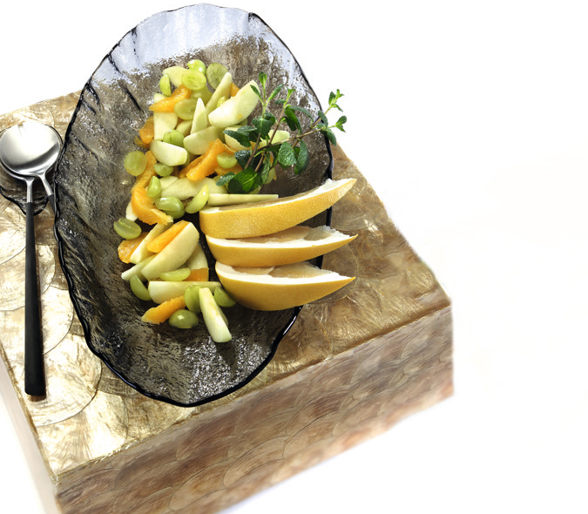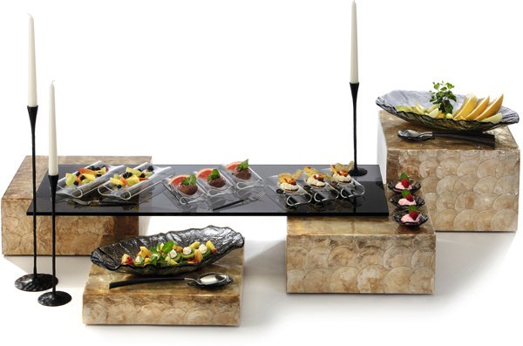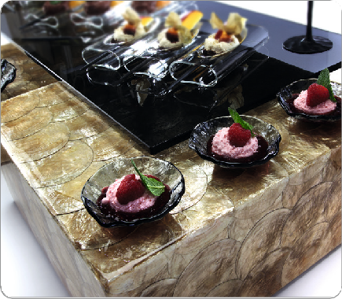“Luxor”

The shimmering displays of the „Luxor“ series enchant by the play of colours of golden shades in variable nuances. This effect is created by high-quality shell imitations, which are arranged fan-shaped on a fibreglass base in sophisticated handcrafting. The honed and highly polished multiple sealing with resin (Polyresin), emphasizes the pattern and the pearlescent shine of the gold-coloured discs and provides the surface with a striking depth effect.

The buffet cuboids are available in heights of 8, 16 and 24 cm and are therefore compatible with many other displays of the Zieher system. The 38 x 38 cm large bearing surface can be used directly for presentation purposes or as a basis for buffet platters or stairs of various kinds.

„Luxor“ adds a touch of extravagance to both the modern and classic ambience, setting extraordinary accents in any environment.

WWW.ZIEHER.COM

03/2022
Zieher KG, Kulmbacher Straße 15, D - 95502 Himmelkron • marketing: +49 9273 9273-68 • presse@zieher.com
In our press area on www.zieher.com you will find all press releases including visual material to download.

