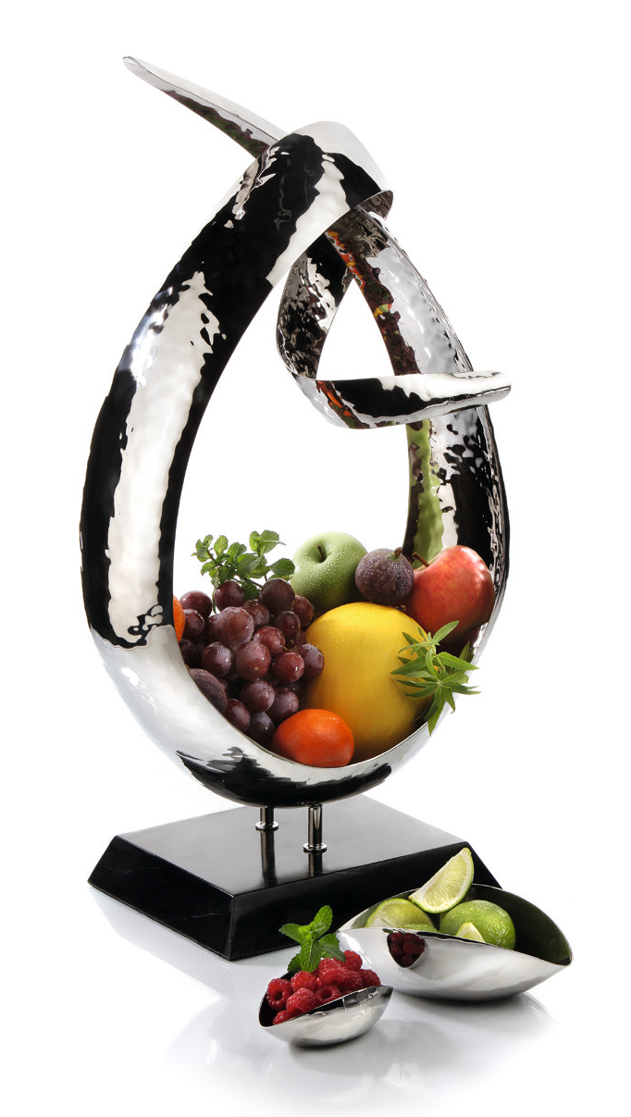“Loop” – precious bowl or artful sculpture?

Twisted and entwined tails, hammered stainless steel on a base of black marble and the imposing height of almost 70 cm will leave a lasting impression. Whether containing fruit or by itself, the effect is guaranteed. These elaborately handcrafted, unique items will capture the eye from every angle. The asymmetrical shape and the irregular structure of the highly polished surface generate fascinating reflec- tions and exciting light effects.

Wether in a suite, on the buffet, in the lobby or at the reception, filled with fruit or creative arrangements – “Loop” is impressive and fasci- nating at the same time.

More information: WWW.ZIEHER.COM

03/2022
Zieher KG, Kulmbacher Straße 15, D - 95502 Himmelkron • marketing: +49 9273 9273-68 • presse@zieher.com
In our press area on www.zieher.com you will find all press releases including visual material to download.

