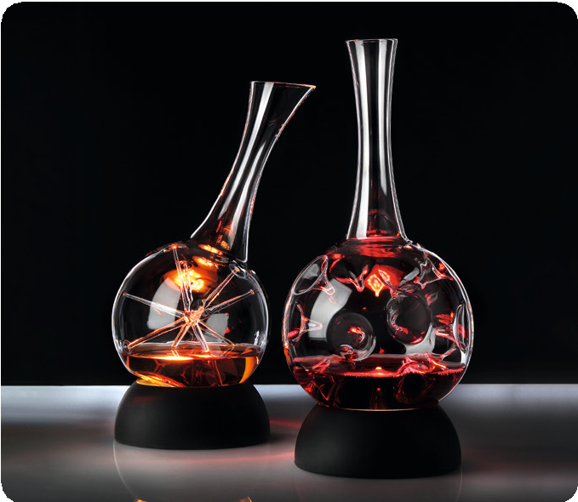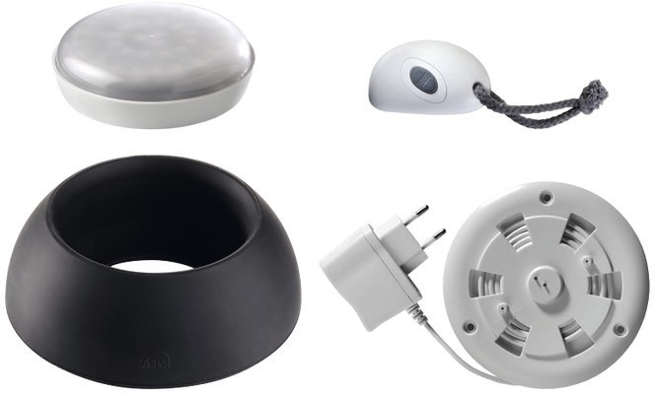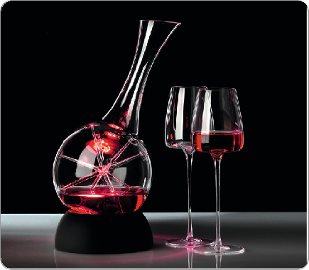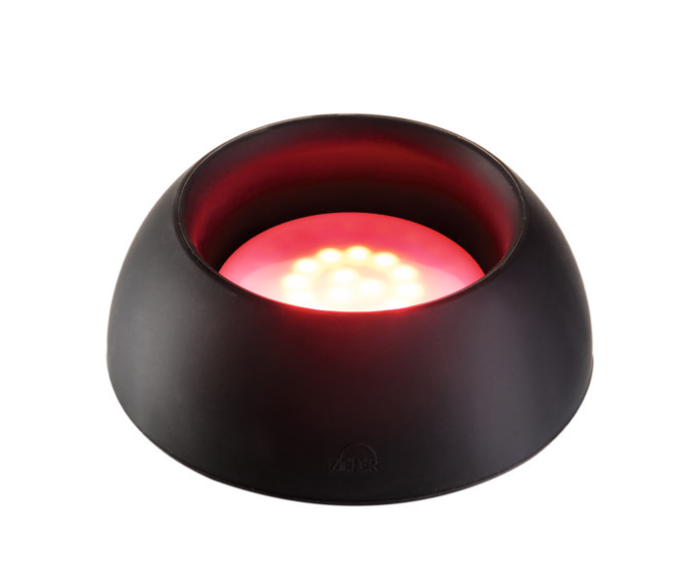Spot on!

This new version of the basic ring for the Eddy and Star decanter offers the chance to put served wine in the spotlight.

The rechargeable Zieher LED light fits exactly into the cavity at the bottom part of the ring and thus can put the served wine in the
decanter into the limelight. In the beginning the illumination effect in the filled decanter can be very unobstrusive when serving strongly pigmented red wine. But at a decreasing level the play of light and colours becomes way more and more intense in an exciting way.

These accessories are also suitable to illuminate glass bowls and –
platters.

LED-Light and remote control maintain also in combination with the ring their known options such as adjustable brightness, 7 different colours and various colour changing functions. All components (Ring, light, remote control and charger) are available either as single parts or as a set in a gift box.

The chargers are available with an EU, US resp. UK plug.

WWW.ZIEHER.COM

03/2022
Zieher KG, Kulmbacher Straße 15, D - 95502 Himmelkron • marketing: +49 9273 9273-68 • presse@zieher.com
In our press area on www.zieher.com you will find all press releases including visual material to download.

