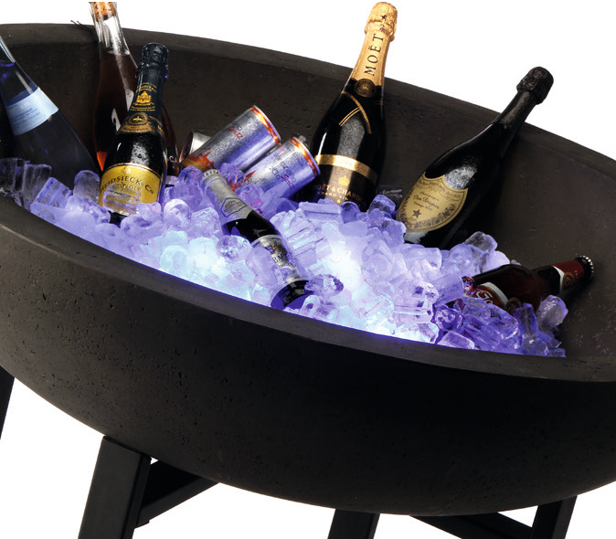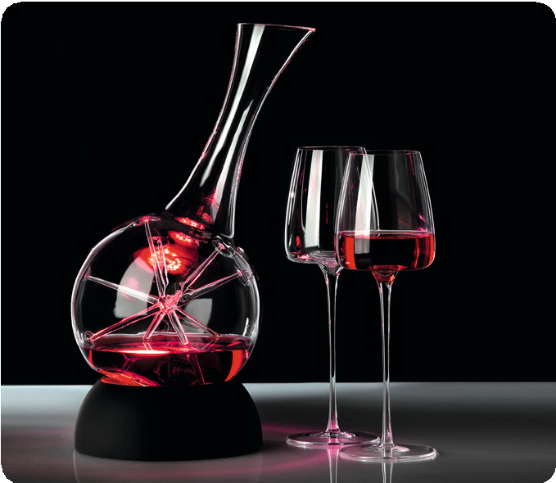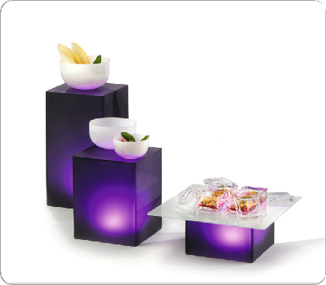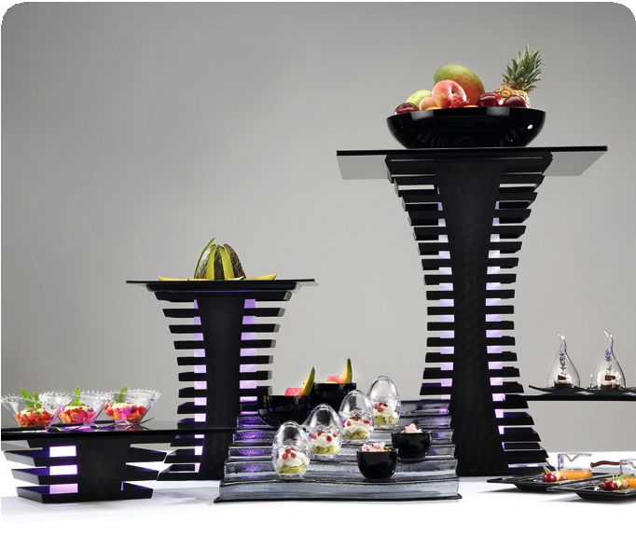Rechargeable LED-light with radio remote control

The compact rechargeable LED light can be adjusted with a remote control. It allows the choice of colors with a range of up to 15 m without having to dismantle the buffet. 7 light colors and 3
brightness levels are available. As a result, they can be used flexibly in various buffet systems from Zieher and are independent of mains connections.

Waterproof to a depth of one meter, it can be placed e.B. directly in ice and let each champagne bowl shine in a special light.

In combination with a base ring, the light can also be used for the decanters Eddy and Star to stage served wine in an atmospheric way.

WWW.ZIEHER.COM

03/2022
Zieher KG, Kulmbacher Straße 15, D - 95502 Himmelkron • marketing: +49 9273 9273-68 • presse@zieher.com
In our press area on www.zieher.com you will find all press releases including visual material to download.

