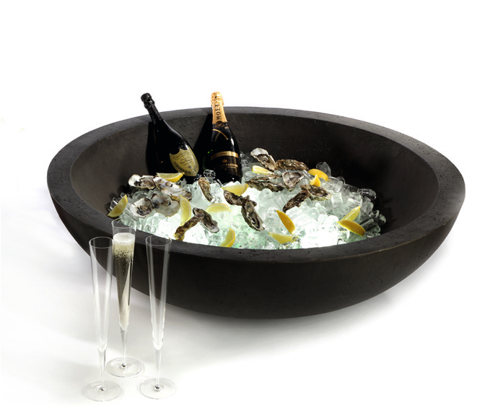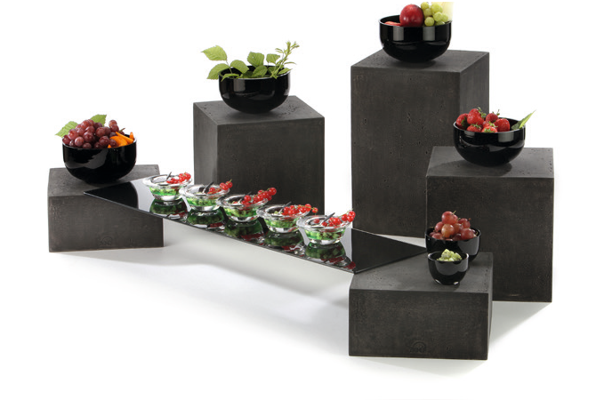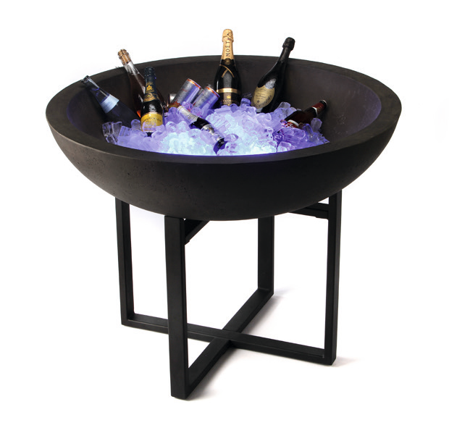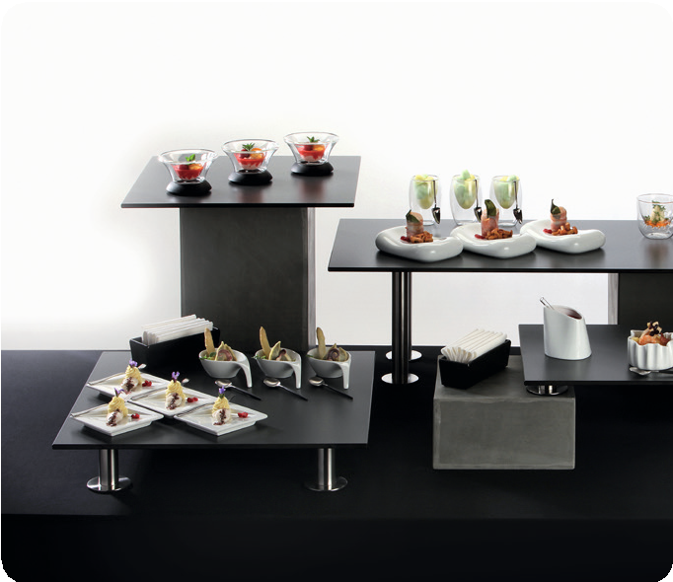“Konkret!” – Distinct design for highest flexibility!

Plain lines, neutral shapes and two different colour variations put your food presentation into focus and offer a maximum of flexibility, while at the same time, using the available space at your buffet most effectively. Maximum reduced shapes in combination with the rough look of concrete - “Konkret!” blends in particularly well with modern architecture. “Less is more” is the motto! Both variants of the displays (light grey and dark grey) are available in eight sizes.

The XXL bowl in dark-grey concrete look inspires by its enormous size and the low weight. In empty state, it can easily be carried by one person. A filigree, but extremely solid stand made of powder- coated steel forms the perfect basis. A round glass plate separates ice from melting water and at the same time creates space for the Zieher rechargeable LED-light, which allows the illumination of the ice in striking colours. No matter if placed on the buffet table or on the stand - this bowl will leave a permanent impression on your guests

The displays consist of a mixture of fibreglass and stone and therefore offer the deceptively genuine optics of concrete combined with low weight and high stability, which greatly facilitates handling. The puristic flair of that system will be intensified by using glass platters.

WWW.ZIEHER.COM

03/2022
Zieher KG, Kulmbacher Straße 15, D - 95502 Himmelkron • marketing: +49 9273 9273-68 • presse@zieher.com
In our press area on www.zieher.com you will find all press releases including visual material to download.

