“Glow” – reframing the buffet!

Filigree displays and frames with integrated lighting form the basis of the “Glow” system.

The matt black coating of these slim but still extremely sturdy lighting objects remains discreetly in the background and leaves the presentation of dishes to the warm and glare-free light.

“Glow” is a flexible system that creates unmatched buffet stagings. The filigree construction not only allows food and beverages to be presented on the displays, their inner side also creates enough space to effectively present delicacies in the right light.

All elements can be used lying or upright and create presentation levels at different heights – the basis for varied and appealing buffet arrangements. Two connecting boards made of bent sheet metal can be attached as desired and thus enable the flexib le construction of several elements – even across corners. Matching buffet platters made of glass or laminated plastic, as well as trays made of melamine, complete the system.

Zieher buffet systems have been inspiring with innovative lighting concepts for many years. In “Glow”, this is now firmly integrated for the first time. The resulting subtle look of these lighting objects creates completely new facets of an atmospheric buffet ambience.

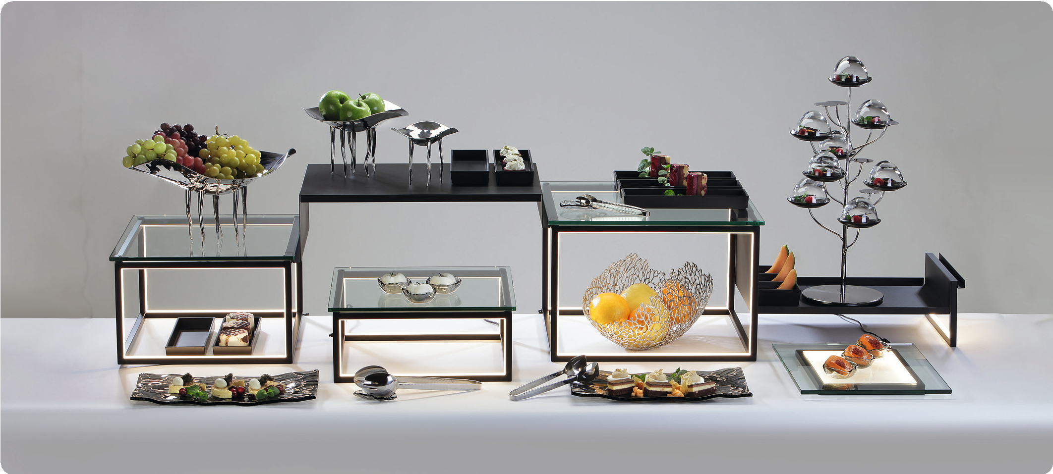

03/2022
Zieher KG, Kulmbacher Straße 15, D - 95502 Himmelkron • marketing: +49 9273 9273-68 • presse@zieher.com
In our press area on www.zieher.com you will find all press releases including visual material to download.

