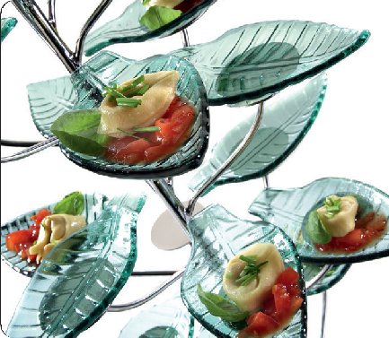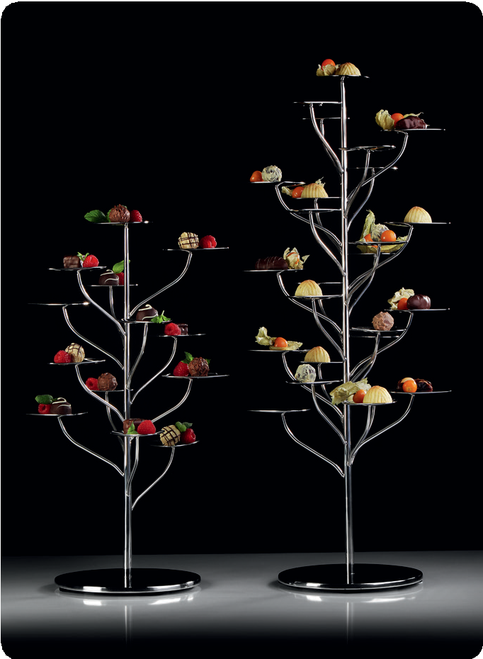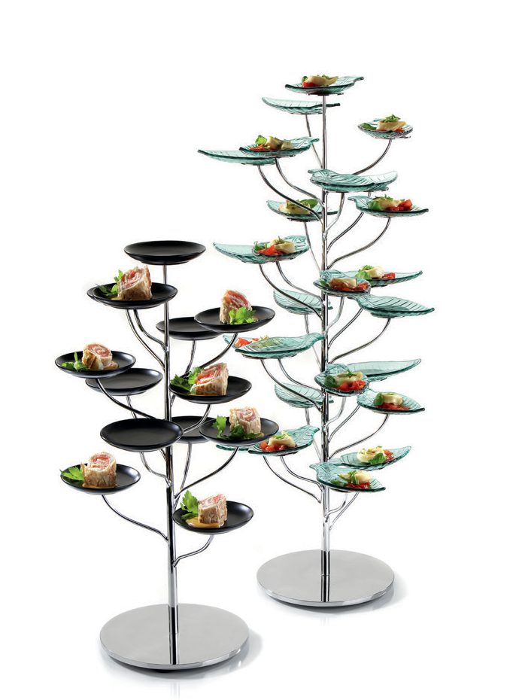“Flower-Tree“ / “Flex-Tree“ - A tree to dream of!

“Flower-Tree“
On 13 resp. 25 levels, these trees offer the possibility to present and showcase finger food, petit-fours and other delicacies. Also a selec- tion of jam in handy jars can be presented in an appealing way as well as fresh apples which, placed on the leaves, invite to take one. These masterpieces of craftsmanship also accentuate the beauty of each lobby by its decorative character.

The shape of the leaves is based on the already existing plateau plates and “Flower-Tower” etageres. Especially on the buffet, this opens up the option to arrange the buffet installations diversified, but nevertheless harmoniously and variable.

“Flex-Tree”
The “Flex-Tree” enthuses by its versatility! On these trees, plain discs replace the fixed leaves. With a diameter of 5.5 cm, they offer suffi- cient space to equip the tree either with glass, porcelain or stainless steel miniatures.

To be on the safe side, they can be placed on black or white anti-slip silicone pads. This reduces the sound emission and at the same time increases the stability of the used miniatures.

All trees are made of massive stainless steel and are accurately high gloss polished. The 8 mm thick foot is the perfect base and guaran- tees a safe stand.

More information: WWW.ZIEHER.COM

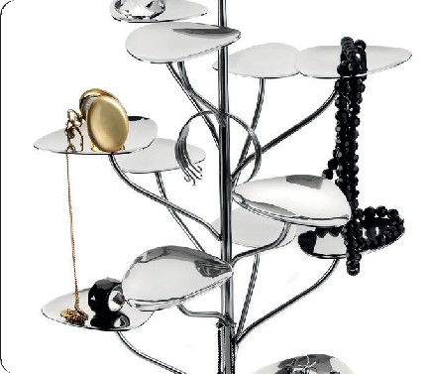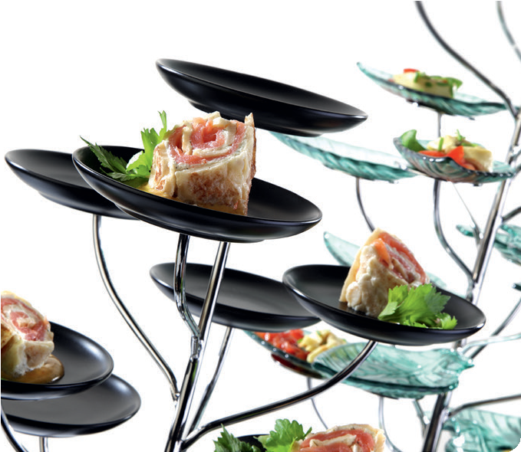

03/2020
Zieher KG, Kulmbacher Straße 15, D - 95502 Himmelkron • marketing: +49 9273 9273-68 • presse@zieher.com
In our press area on www.zieher.com you will find all press releases including visual material to download.

